

**Course-Code: CS2005**

**Database Systems**

# Assignment 3

# Topic: Healthcare Scheduling System

# Diagraming Software Tool Used: Lucid Chart

**Submitted By:** Khursheed Alam Khan

**Roll#:**  20i-0496

**Section:** SE-R

**Submitted to:** Mam Javaria Imtiaz

**Submitted on:** 14th May 2022

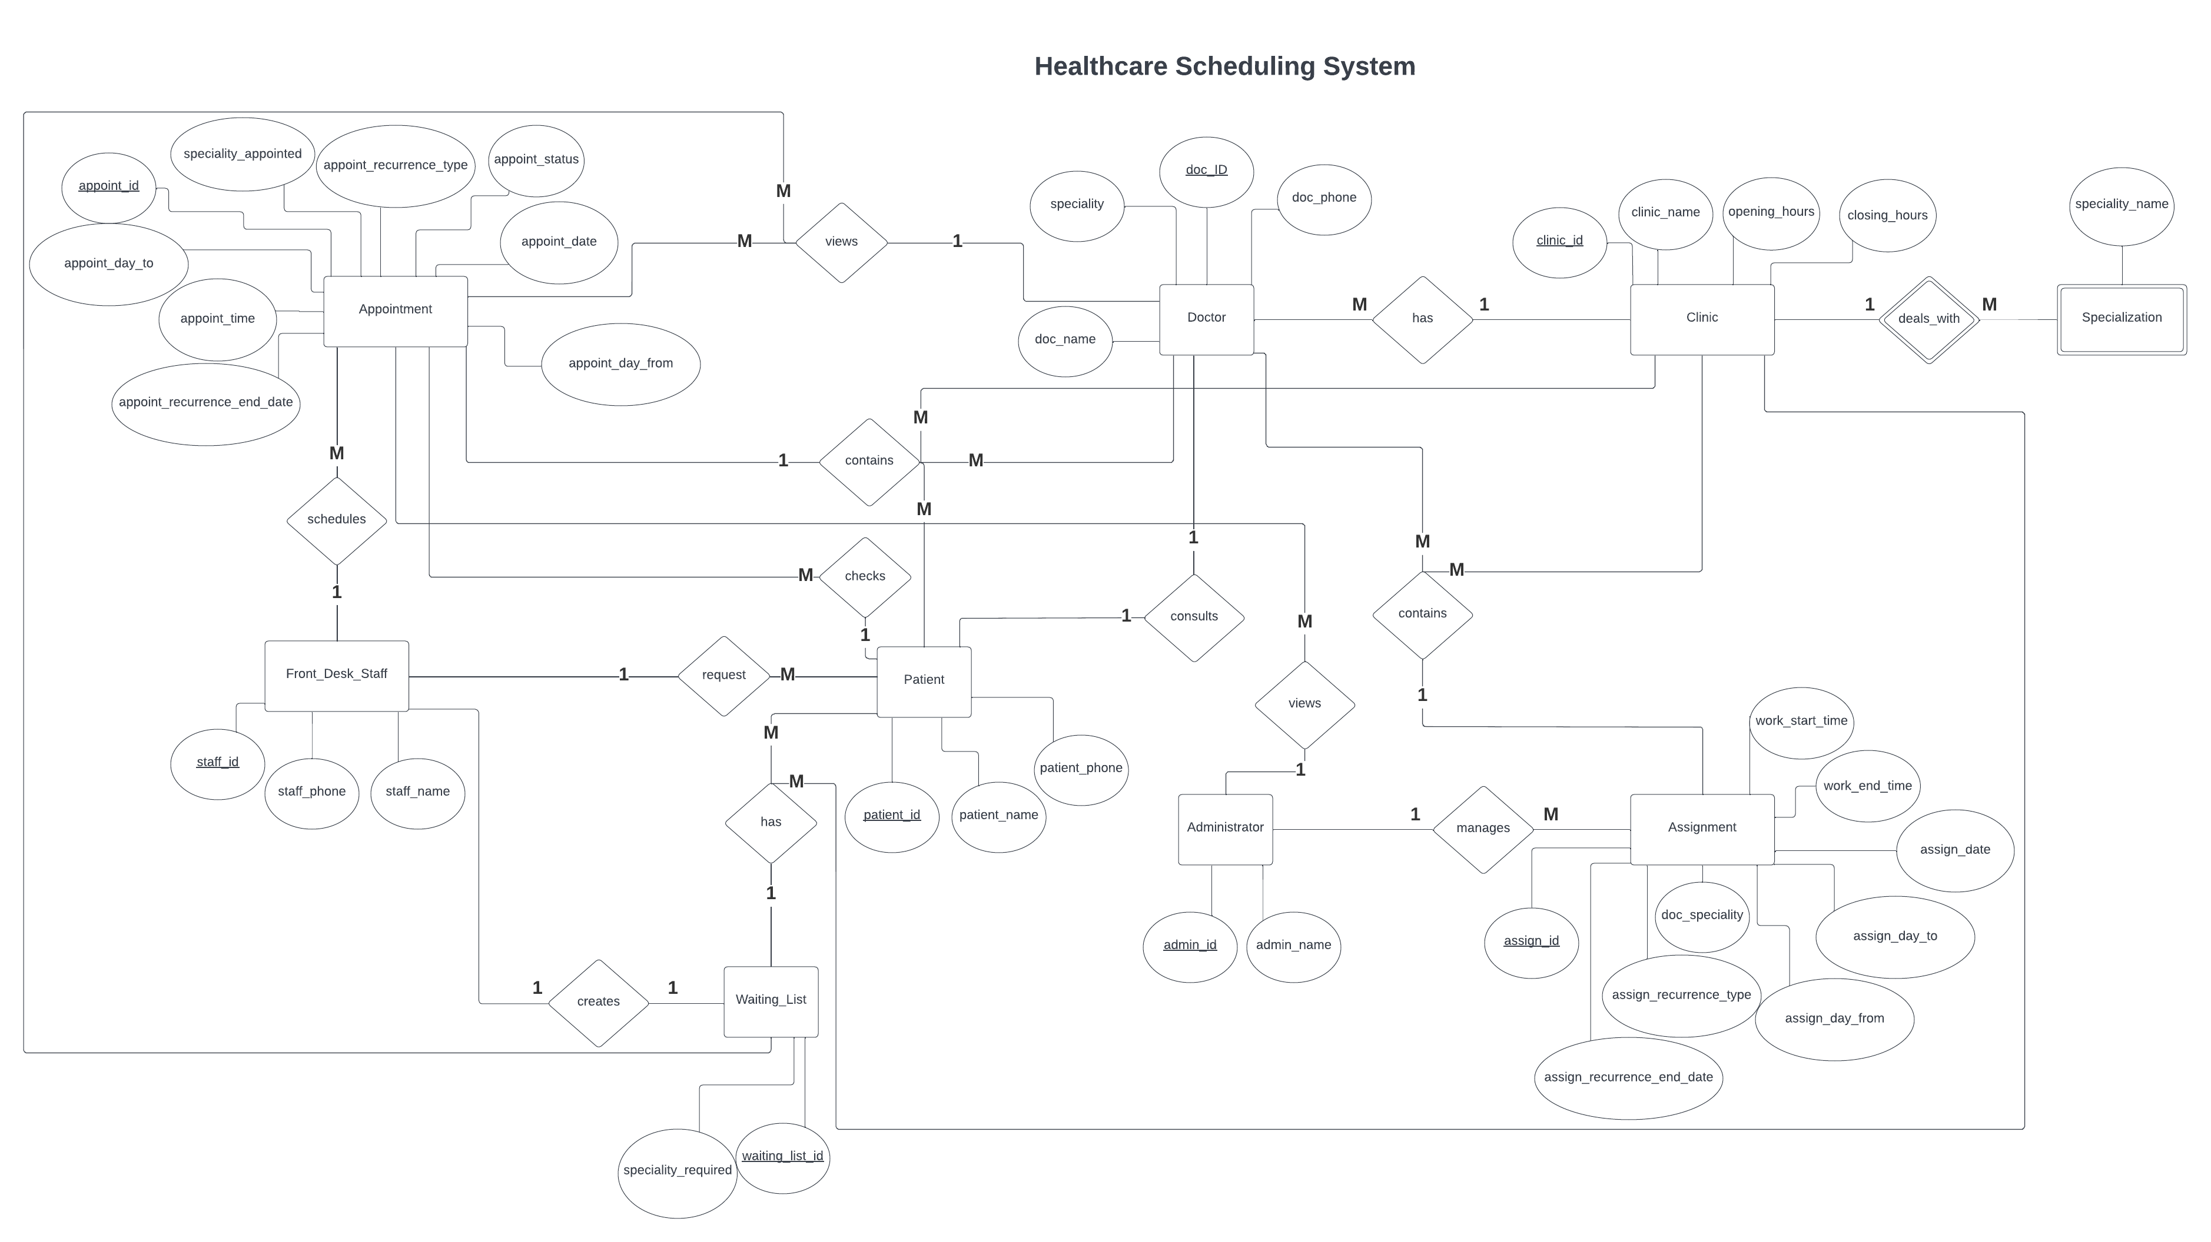**ER Diagram:** Healthcare Scheduling System

* In my ERD, I identified the following Entities:
* Doctor
* Patient
* Clinic
* Administrator
* Front_Desk_Staff
* Assignment
* Appointment
* Waiting_List
* Specialization

The attributes that I identified for **Doctor** includes the following:

* Doc_Id
* Doc_Name
* Doc_Phone
* Speciality

The attributes that I identified for **Patient** includes the following:

* Patient_Id
* Patient_Name
* Patient_Phone

The attributes that I identified for **Clinic** includes the following:

* Clinic_Id
* Clinic_Name
* Opening_Hours
* Closing_Hours

The attributes that I identified for **Administrator** includes the following:

* Admin_Id
* Admin_Name

The attributes that I identified for **Front_Desk_Staff** includes the following:

* Staff_Id
* Staff_Name
* Staff_Phone

The attributes that I identified for **Assignment** includes the following:

* Assign_Id
* Doc_Speciality
* Assign_Recurrence_Type
* Assign_Recurrence_End_Date
* Assign_Day_From
* Assign_Day_To
* Assign_Date
* Work_Start_Time
* Work_End_Time

The attributes that I identified for **Appointment** includes the following:

* Appoint_Id
* Speciality_Appointed
* Appoint_Recurrence_Type
* Appoint_Recurrence_End_Date
* Appoint_Day_From
* Appoint_Day_To
* Appoint_Date
* Appoint_Time
* Appoint_Status

The attributes that I identified for **Waiting_List** includes the following:

* Waiting_List_Id
* Speciality_Required

The attributes that I identified for **Specialization** includes the following:

* Speciality_Name
* In my ERD, I also identified the following Primary keys for the following Entities:

1. **Doctor:**

Primary Key: Doc_Id

1. **Patient:**

Primary Key: Patient_Id

1. **Clinic:**

Primary Key: Clinic_Id

1. **Administrator:**

Primary Key: Admin_Id

1. **Front_Desk_Staff:**

Primary Key: Staff_Id

1. **Assignment:**

Primary Key: Assign_Id

1. **Appointment:**

Primary Key: Appoint_Id

1. **Waiting_List:**

Primary Key: Waiting_List_Id

* An Important note is that for the Entity **Specialization,**  I have not included any primary key because **Specialization** is a weak entity.

* In my ERD, I have also identified the following relationships between the entities:

1. **One-to-One:**

* Front_Desk_Staff – Creates - Waiting_List
* Patient – Consults – Doctor

1. **One-to-Many**

* Doctor – Views – Appointment
* Doctor – Views – Waiting_List
* Patient – Request – Front_Desk_Staff
* Waiting_List – Has – Patient
* Waiting_List – Has – Clinic
* Patient – Checks – Appointment
* Appointment – Contains – Clinic
* Appointment – Contains – Doctor
* Appointment – Contains – Patient
* Administrator – Manages – Assignment
* Administrator – Views – Appointment
* Assignment – Contains – Doctor
* Assignment – Contains – Clinic
* Clinic – Deals_With – Specialization
* Clinic – Has – Doctor
* Front_Desk_Staff – Schedules – Appointment

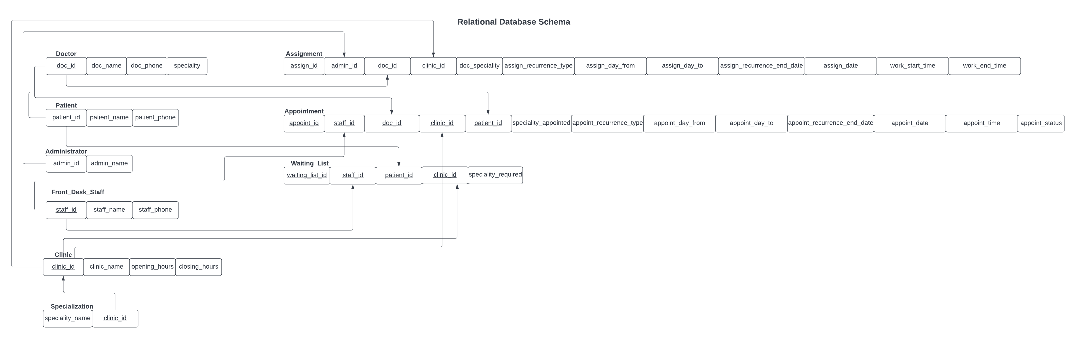**Relational Database Schema:** Healthcare Scheduling System

* My Relational Database Schema includes following important information for each Relation/Table:

1. **Doctor:**

* Doc_Id
* Doc_Name
* Doc_Phone
* Specialty

*Here the Primary Key is: Doc_Id.

1. **Patient:**

* Patient_Id
* Patient_Name
* Patient_Phone

*Here the Primary Key is: Patient_Id.

1. **Administrator:**

* Admin_Id
* Admin_Name

*Here the Primary Key is: Admin_Id.

1. **Front_Desk_Staff:**

* Staff_Id
* Staff_Name
* Staff_Phone

*Here the Primary Key is: Staff_Id.

1. **Clinic:**

* Clinic_Id
* Clinic_Name
* Opening_Hours
* Closing_Hours

*Here the Primary Key is: Clinic_Id.

1. **Specialization:**

* Speciality_Name
* Clinic_Id

*Here I am using Clinic_Id as a foreign from referenced from the table **Clinic**

1. **Assignment:**

* Assign_Id
* Admin_Id
* Doc_Id
* Clinic_Id
* Doc_Speciality
* Assign_Recurrence_Type
* Assign_Day_From
* Assign_Day_To
* Assign_Recurrence_End_Date
* Assign_Date
* Work_Start_Time
* Work_End_Time

*Here the Primary Key is: Assign_Id.

*Here I am using Admin_Id as a foreign from referenced from the table **Administrator**

*Here I am using Doc_Id as a foreign from referenced from the table **Doctor**

*Here I am using Clinic_Id as a foreign from referenced from the table **Clinic**

1. **Appointment:**

* Appoint_Id
* Staff_Id
* Doc_Id
* Clinic_Id
* Patient_Id
* Speciality_Appointed
* Appoint_Recurrence_Type
* Appoint_Day_From
* Appoint_Day_To
* Appoint_Recurrence_End_Date
* Appoint_Date
* Appoint_Time
* Appoint_Status

*Here the Primary Key is: Appoint_Id.

*Here I am using Staff_Id as a foreign from referenced from the table **Front_Desk_Staff**

*Here I am using Doc_Id as a foreign from referenced from the table **Doctor**

*Here I am using Clinic_Id as a foreign from referenced from the table **Clinic**

*Here I am using Patient_Id as a foreign from referenced from the table **Patient**

1. **Waiting_List:**

* Waiting_List_Id
* Staff_Id
* Patient_Id
* Clinic_Id
* Speciality_Required

*Here the Primary Key is: Waiting_List_Id.

*Here I am using Staff_Id as a foreign from referenced from the table **Front_Desk_Staff**

*Here I am using Patient_Id as a foreign from referenced from the table **Patient**

*Here I am using Clinic_Id as a foreign from referenced from the table **Clinic**

**SQL queries for Table, Constraints Creation:** Healthcare Scheduling System

* I have used the following SQL Queries and constraints while creating the tables for each entity:

1. **Doctor:**

-- Create Doctor Table

CREATE TABLE DOCTOR

( Doc_Id INT NOT NULL,

Doc_Name VARCHAR(255) NOT NULL,

Doc_Phone VARCHAR(255) NOT NULL,

Speciality VARCHAR(255) NOT NULL

PRIMARY KEY (Doc_Id)

);

*The constraints:

* Doc_Id is primary Key of type integer and it cannot be NULL
* Doc_Name is a Varchar(255) data type that cannot be NULL
* Doc_Phone is a Varchar(255) data type that cannot be NULL
* Speciality is a Varchar(255) data type that cannot be NULL

1. **Patient:**

-- Create Patient Table

CREATE TABLE PATIENT

( Patient_Id INT NOT NULL,

Patient_Name VARCHAR(255) NOT NULL,

Patient_Phone VARCHAR(255) NOT NULL,

PRIMARY KEY (Patient_Id)

);

*The constraints:

* Patient_Id is primary Key of type Integer and it cannot be NULL
* Patient_Name is a Varchar(255) data type that cannot be NULL
* Patient_Phone is a Varchar(255) data type that cannot be NULL

1. **Administrator:**

-- Create Administrator Table

CREATE TABLE ADMINISTRATOR

( Admin_Id INT NOT NULL,

Admin_Name VARCHAR(255) NOT NULL,

PRIMARY KEY (Admin_Id)

);

*The constraints:

* Admin_Id is primary Key of type Integer and it cannot be NULL
* Admin_Name is a Varchar(255) data type that cannot be NULL

1. **Front_Desk_Staff:**

-- Create Front_Desk_Staff Table

CREATE TABLE FRONT_DESK_STAFF

( Staff_Id INT NOT NULL,

Staff_Name VARCHAR(255) NOT NULL,

Staff_Phone VARCHAR(255) NOT NULL,

PRIMARY KEY (Staff_Id)

);

*The constraints:

* Staff_Id is primary Key of type Integer and it cannot be NULL
* Staff_Name is a Varchar(255) data type that cannot be NULL
* Staff_Phone is a Varchar(255) data type that cannot be NULL

1. **Clinic:**

-- Create Clinic Table

CREATE TABLE CLINIC

( Clinic_Id INT NOT NULL,

Clinic_Name VARCHAR(255) NOT NULL,

Opening_hours TIME NOT NULL,

Closing_hours TIME NOT NULL,

PRIMARY KEY (Clinic_Id)

);

*The constraints:

* Clinic_Id is primary Key of type Integer and it cannot be NULL
* Clinic_Name is a Varchar(255) data type that cannot be NULL
* Opening_Hours is a TIME data type that cannot be NULL
* Closing_Hours is a TIME data type that cannot be NULL

1. **Specialization:**

-- Create Specialization Table

CREATE TABLE SPECIALIZATION

( Speciality_Name VARCHAR(255) NOT NULL,

Clinic_Id INT FOREIGN KEY REFERENCES CLINIC(Clinic_Id)

);

*The constraints:

* Speciality_Name is a Varchar(255) data type that cannot be NULL
* Clinic_Id is Foreign Key of type Integer that cannot be NULL, and it is referenced from the table **Clinic**

1. **Assignment:**

-- Create Assignment Table

CREATE TABLE ASSIGNMENT

( Assign_Id INT NOT NULL,

Admin_ID INT FOREIGN KEY REFERENCES ADMINISTRATOR(Admin_Id),

Doc_Id INT FOREIGN KEY REFERENCES DOCTOR(Doc_Id),

Clinic_Id INT FOREIGN KEY REFERENCES CLINIC(Clinic_Id),

Doc_Speciality VARCHAR(255) NOT NULL,

Assign_Recurrence_Type VARCHAR(255) CHECK(Assign_Recurrence_Type = 'Daily' or Assign_Recurrence_Type = 'Weekly' or Assign_Recurrence_Type = 'Monthly') NOT NULL,

Assign_Day_From VARCHAR(255) CHECK(Assign_Day_From = 'Monday' or Assign_Day_From = 'Tuesday' or Assign_Day_From = 'Wednesday' or Assign_Day_From = 'Thursday' or Assign_Day_From = 'Friday' or Assign_Day_From = 'Saturday' or Assign_Day_From = 'Sunday') NOT NULL,

Assign_Day_To VARCHAR(255) CHECK(Assign_Day_To = 'Monday' or Assign_Day_To = 'Tuesday' or Assign_Day_To = 'Wednesday' or Assign_Day_To = 'Thursday' or Assign_Day_To = 'Friday' or Assign_Day_To = 'Saturday' or Assign_Day_To = 'Sunday') NOT NULL,

Assign_Recurrence_End_Date DATE NOT NULL,

Assign_Date DATE NOT NULL,

Work_Start_Time TIME NOT NULL,

Work_End_Time TIME NOT NULL,

PRIMARY KEY (Assign_Id)

);

*The constraints:

* Assign_Id is primary Key of type Integer and it cannot be NULL
* Admin_Id is Foreign Key of type Integer that cannot be NULL, and it is referenced from the table **Administrator**
* Doc_Id is Foreign Key of type Integer that cannot be NULL, and it is referenced from the table **Doctor**
* Clinic_Id is Foreign Key of type Integer that cannot be NULL, and it is referenced from the table **Clinic**
* Doc_Speciality is a Varchar(255) data type that cannot be NULL
* Assign_Recurrence_Type is Varchar(255) data type that cannot be null and it has a check condition that the Assign_Recurrence_Type can only contain ‘Weekly’, ‘Monthly’, or ‘Daily’ strings
* Assign_Day_From is Varchar(255) data type that cannot be null and it has a check condition that the Assign_Day_From can only contain ‘Monday’, ‘Tuesday’, ‘Wednesday’, ‘Thursday’, ‘Friday’, ‘Saturday’, or ‘Sunday’ strings
* Assign_Day_To is Varchar(255) data type that cannot be null and it has a check condition that the Assign_Day_To can only contain ‘Monday’, ‘Tuesday’, ‘Wednesday’, ‘Thursday’, ‘Friday’, ‘Saturday’, or ‘Sunday’ strings
* Assign_Recurrence_End_Date is a Date data type that cannot be NULL
* Assign_Date is a Date data type that cannot be NULL
* Work_Start_Time is a Time data type that cannot be NULL
* Work_End_Time is a Time data type that cannot be NULL

1. **Appointment:**

-- Create Appointment Table

CREATE TABLE APPOINTMENT

( Appoint_Id INT NOT NULL,

Staff_ID INT FOREIGN KEY REFERENCES FRONT_DESK_STAFF(Staff_Id),

Doc_Id INT FOREIGN KEY REFERENCES DOCTOR(Doc_Id),

Clinic_Id INT FOREIGN KEY REFERENCES CLINIC(Clinic_Id),

Patient_Id INT FOREIGN KEY REFERENCES PATIENT(Patient_Id),

Speciality_Appointed VARCHAR(255) NOT NULL,

Appoint_Recurrence_Type VARCHAR(255) CHECK(Appoint_Recurrence_Type = 'Daily' or Appoint_Recurrence_Type = 'Weekly' or Appoint_Recurrence_Type = 'Monthly') NOT NULL,

Appoint_Day_From VARCHAR(255) CHECK(Appoint_Day_From = 'Monday' or Appoint_Day_From = 'Tuesday' or Appoint_Day_From = 'Wednesday' or Appoint_Day_From = 'Thursday' or Appoint_Day_From = 'Friday' or Appoint_Day_From = 'Saturday' or Appoint_Day_From = 'Sunday') NOT NULL,

Appoint_Day_To VARCHAR(255) CHECK(Appoint_Day_To = 'Monday' or Appoint_Day_To = 'Tuesday' or Appoint_Day_To = 'Wednesday' or Appoint_Day_To = 'Thursday' or Appoint_Day_To = 'Friday' or Appoint_Day_To = 'Saturday' or Appoint_Day_To = 'Sunday') NOT NULL,

Appoint_Recurrence_End_Date DATE NOT NULL,

Appoint_Date DATE NOT NULL,

Appoint_Time TIME NOT NULL,

Appoint_Status VARCHAR(255) CHECK(Appoint_Status = 'Active' or Appoint_Status = 'Completed'),

PRIMARY KEY (Appoint_ID)

);

*The constraints:

* Appoint_Id is primary Key of type Integer and it cannot be NULL
* Staff_Id is Foreign Key of type Integer that cannot be NULL, and it is referenced from the table **Front_Desk_Staff**
* Doc_Id is Foreign Key of type Integer that cannot be NULL, and it is referenced from the table **Doctor**
* Clinic_Id is Foreign Key of type Integer that cannot be NULL, and it is referenced from the table **Clinic**
* Patient_Id is Foreign Key of type Integer that cannot be NULL, and it is referenced from the table **Patient**
* Speciality_Appointed is a Varchar(255) data type that cannot be NULL
* Appoint_Recurrence_Type is Varchar(255) data type that cannot be null and it has a check condition that the Appoint_Recurrence_Type can only contain ‘Weekly’, ‘Monthly’, or ‘Daily’ strings
* Appoint_Day_From is Varchar(255) data type that cannot be null and it has a check condition that the Appoint_Day_From can only contain ‘Monday’, ‘Tuesday’, ‘Wednesday’, ‘Thursday’, ‘Friday’, ‘Saturday’, or ‘Sunday’ strings
* Appoint_Day_To is Varchar(255) data type that cannot be null and it has a check condition that the Appoint_Day_To can only contain ‘Monday’, ‘Tuesday’, ‘Wednesday’, ‘Thursday’, ‘Friday’, ‘Saturday’, or ‘Sunday’ strings
* Appoint_Recurrence_End_Date is a Date data type that cannot be NULL
* Appoint_Date is a Date data type that cannot be NULL
* Appoint_Time is a Time data type that cannot be NULL
* Appoint_Status is a Varchar(255) data type that cannot be NULL and it has a check condition that the Appoint_Status can only contain either an ‘Active’ or a ‘Completed’ string status

1. **Waiting_List:**

-- Create Waiting_List Table

CREATE TABLE WAITING_LIST

( Waiting_List_Id INT NOT NULL,

Staff_Id INT FOREIGN KEY REFERENCES FRONT_DESK_STAFF(Staff_Id),

Patient_Id INT FOREIGN KEY REFERENCES PATIENT(Patient_Id),

Clinic_Id INT FOREIGN KEY REFERENCES CLINIC(Clinic_Id),

Speciality_required VARCHAR(255) NOT NULL,

PRIMARY KEY (Waiting_List_Id)

);

*The constraints:

* Waiting_List_Id is primary Key of type Integer and it cannot be NULL
* Staff_Id is Foreign Key of type Integer that cannot be NULL, and it is referenced from the table **Front_Desk_Staff**
* Patient_Id is Foreign Key of type Integer that cannot be NULL, and it is referenced from the table **Patient**
* Clinic_Id is Foreign Key of type Integer that cannot be NULL, and it is referenced from the table **Clinic**
* Speciality_required is a Varchar(255) data type that cannot be NULL

**SQL queries for Data insertion and Fetching:** Healthcare Scheduling System

* I have used the following SQL Queries to insert data into the tables for each entity:

1. **Doctor:**

-- Insert Data into DOCTOR Table--

INSERT INTO DOCTOR(Doc_Id, Doc_Name, Doc_Phone, Speciality)

VALUES(1000, 'Khursheed', '9100-8864523', 'Gastology');

INSERT INTO DOCTOR(Doc_Id, Doc_Name, Doc_Phone, Speciality)

VALUES(1001, 'John', '0900-1234567', 'Orthopedics');

INSERT INTO DOCTOR(Doc_Id, Doc_Name, Doc_Phone, Speciality)

VALUES(1002, 'Oliver', '0400-7534237', 'Oncology');

INSERT INTO DOCTOR(Doc_Id, Doc_Name, Doc_Phone, Speciality)

VALUES(1003, 'Watson', '1200-3736831', 'Cardiology');

INSERT INTO DOCTOR(Doc_Id, Doc_Name, Doc_Phone, Speciality)

VALUES(1004, 'Khan', '0350-836782', 'Dermatology');

INSERT INTO DOCTOR(Doc_Id, Doc_Name, Doc_Phone, Speciality)

VALUES(1005, 'Adam', '0120-466672', 'Radiology');

INSERT INTO DOCTOR(Doc_Id, Doc_Name, Doc_Phone, Speciality)

VALUES(1006, 'Jimmy', '222-222476', 'Gastology');

INSERT INTO DOCTOR(Doc_Id, Doc_Name, Doc_Phone, Speciality)

VALUES(1007, 'Zafina', '876-23453226', 'Oncology');

1. **Patient:**

-- Insert Data into PATIENT Table--

INSERT INTO PATIENT(Patient_Id, Patient_Name, Patient_Phone)

VALUES(500, 'Willow', '100-234523');

INSERT INTO PATIENT(Patient_Id, Patient_Name, Patient_Phone)

VALUES(501, 'Tina', '123-244555');

INSERT INTO PATIENT(Patient_Id, Patient_Name, Patient_Phone)

VALUES(502, 'Lida', '231-321333');

INSERT INTO PATIENT(Patient_Id, Patient_Name, Patient_Phone)

VALUES(503, 'Olivia', '892-333444');

INSERT INTO PATIENT(Patient_Id, Patient_Name, Patient_Phone)

VALUES(504, 'Bella', '999-111222');

INSERT INTO PATIENT(Patient_Id, Patient_Name, Patient_Phone)

VALUES(505, 'Luna', '666-666623');

INSERT INTO PATIENT(Patient_Id, Patient_Name, Patient_Phone)

VALUES(506, 'Bahadur', '777-677773');

INSERT INTO PATIENT(Patient_Id, Patient_Name, Patient_Phone)

VALUES(507, 'Wong', '873-123423');

INSERT INTO PATIENT(Patient_Id, Patient_Name, Patient_Phone)

VALUES(508, 'Jhonny', '9023-46624');

INSERT INTO PATIENT(Patient_Id, Patient_Name, Patient_Phone)

VALUES(509, 'Peter', '9112-31344');

INSERT INTO PATIENT(Patient_Id, Patient_Name, Patient_Phone)

VALUES(510, 'Veronica', '7823-783551');

1. **Administrator:**

-- Insert Data into Administrator Table--

INSERT INTO ADMINISTRATOR(Admin_Id, Admin_Name)

VALUES(1, 'Frenzo');

1. **Front_Desk_Staff:**

-- Insert Data into FRONT_DESK_STAFF Table--

INSERT INTO FRONT_DESK_STAFF(Staff_Id, Staff_Name, Staff_Phone)

VALUES(10, 'Xardas', '331-333331');

1. **Clinic:**

-- Insert Data into CLINIC Table--

INSERT INTO CLINIC(Clinic_Id, Clinic_Name, Opening_Hours, Closing_Hours)

VALUES(200, 'Broklyn', '07:15:00', '18:00:00');

INSERT INTO CLINIC(Clinic_Id, Clinic_Name, Opening_Hours, Closing_Hours)

VALUES(201, 'Manhattan', '05:00:00', '12:00:00');

INSERT INTO CLINIC(Clinic_Id, Clinic_Name, Opening_Hours, Closing_Hours)

VALUES(202, 'Yorker', '08:30:00', '21:00:00');

INSERT INTO CLINIC(Clinic_Id, Clinic_Name, Opening_Hours, Closing_Hours)

VALUES(203, 'SandyShore', '05:30:00', '23:30:00');

INSERT INTO CLINIC(Clinic_Id, Clinic_Name, Opening_Hours, Closing_Hours)

VALUES(204, 'Miami', '09:15:00', '19:00:00');

INSERT INTO CLINIC(Clinic_Id, Clinic_Name, Opening_Hours, Closing_Hours)

VALUES(205, 'Bermuda', '04:00:00', '23:59:00');

1. **Specialization:**

-- Insert Data into SPECIALIZATION Table--

INSERT INTO SPECIALIZATION(Speciality_Name, Clinic_Id)

VALUES('Orthopedics', 200);

INSERT INTO SPECIALIZATION(Speciality_Name, Clinic_Id)

VALUES('Oncology', 200);

INSERT INTO SPECIALIZATION(Speciality_Name, Clinic_Id)

VALUES('Gastology', 201);

INSERT INTO SPECIALIZATION(Speciality_Name, Clinic_Id)

VALUES('Orthopedics', 201);

INSERT INTO SPECIALIZATION(Speciality_Name, Clinic_Id)

VALUES('Oncology', 201);

INSERT INTO SPECIALIZATION(Speciality_Name, Clinic_Id)

VALUES('Dermatology', 202);

INSERT INTO SPECIALIZATION(Speciality_Name, Clinic_Id)

VALUES('Gastology', 202);

INSERT INTO SPECIALIZATION(Speciality_Name, Clinic_Id)

VALUES('Radiology', 203);

INSERT INTO SPECIALIZATION(Speciality_Name, Clinic_Id)

VALUES('Cardiology', 204);

INSERT INTO SPECIALIZATION(Speciality_Name, Clinic_Id)

VALUES('Oncology', 204);

INSERT INTO SPECIALIZATION(Speciality_Name, Clinic_Id)

VALUES('Cardiology', 205);

INSERT INTO SPECIALIZATION(Speciality_Name, Clinic_Id)

VALUES('Dermatology', 205);

1. **Assignment:**

-- Insert Data into ASSIGNMENT Table--

INSERT INTO ASSIGNMENT(Assign_Id, Admin_id, Doc_Id, Clinic_Id, Doc_Speciality, Assign_Recurrence_Type, Assign_Day_From, Assign_Day_To, Assign_Recurrence_End_Date, Assign_Date, Work_Start_Time, Work_End_Time)

VALUES(300, 1, 1000, 202, 'Gastology', 'Weekly', 'Monday', 'Tuesday', '2022-12-31', '2021-05-10', '09:00:00', '12:00:00');

INSERT INTO ASSIGNMENT(Assign_Id, Admin_id, Doc_Id, Clinic_Id, Doc_Speciality, Assign_Recurrence_Type, Assign_Day_From, Assign_Day_To, Assign_Recurrence_End_Date, Assign_Date, Work_Start_Time, Work_End_Time)

VALUES(301, 1, 1004, 202, 'Dermatology', 'Monthly', 'Monday', 'Wednesday', '2022-08-15', '2021-01-01', '09:30:00', '12:30:00');

INSERT INTO ASSIGNMENT(Assign_Id, Admin_id, Doc_Id, Clinic_Id, Doc_Speciality, Assign_Recurrence_Type, Assign_Day_From, Assign_Day_To, Assign_Recurrence_End_Date, Assign_Date, Work_Start_Time, Work_End_Time)

VALUES(302, 1, 1005, 203, 'Radiology', 'Daily', 'Monday', 'Friday', '2023-12-31', '2022-01-03', '06:00:00', '18:59:00');

INSERT INTO ASSIGNMENT(Assign_Id, Admin_id, Doc_Id, Clinic_Id, Doc_Speciality, Assign_Recurrence_Type, Assign_Day_From, Assign_Day_To, Assign_Recurrence_End_Date, Assign_Date, Work_Start_Time, Work_End_Time)

VALUES(303, 1, 1000, 201, 'Gastology', 'Monthly', 'Thursday', 'Friday', '2024-12-12', '2020-01-13', '08:00:00', '10:30:00');

INSERT INTO ASSIGNMENT(Assign_Id, Admin_id, Doc_Id, Clinic_Id, Doc_Speciality, Assign_Recurrence_Type, Assign_Day_From, Assign_Day_To, Assign_Recurrence_End_Date, Assign_Date, Work_Start_Time, Work_End_Time)

VALUES(304, 1, 1001, 200, 'Orthopedics', 'Daily', 'Monday', 'Wednesday', '2024-11-11', '2020-03-15', '08:30:00', '14:59:00');

INSERT INTO ASSIGNMENT(Assign_Id, Admin_id, Doc_Id, Clinic_Id, Doc_Speciality, Assign_Recurrence_Type, Assign_Day_From, Assign_Day_To, Assign_Recurrence_End_Date, Assign_Date, Work_Start_Time, Work_End_Time)

VALUES(305, 1, 1002, 200, 'Oncology', 'Weekly', 'Saturday', 'Sunday', '2025-09-07', '2019-06-23', '09:00:00', '13:30:00');

INSERT INTO ASSIGNMENT(Assign_Id, Admin_id, Doc_Id, Clinic_Id, Doc_Speciality, Assign_Recurrence_Type, Assign_Day_From, Assign_Day_To, Assign_Recurrence_End_Date, Assign_Date, Work_Start_Time, Work_End_Time)

VALUES(306, 1, 1001, 201, 'Orthopedics', 'Weekly', 'Friday', 'Saturday', '2024-11-11', '2020-03-15', '07:30:00', '10:30:00');

INSERT INTO ASSIGNMENT(Assign_Id, Admin_id, Doc_Id, Clinic_Id, Doc_Speciality, Assign_Recurrence_Type, Assign_Day_From, Assign_Day_To, Assign_Recurrence_End_Date, Assign_Date, Work_Start_Time, Work_End_Time)

VALUES(307, 1, 1002, 201, 'Oncology', 'Daily', 'Monday', 'Wednesday', '2025-09-07', '2019-06-23', '06:00:00', '09:30:00');

INSERT INTO ASSIGNMENT(Assign_Id, Admin_id, Doc_Id, Clinic_Id, Doc_Speciality, Assign_Recurrence_Type, Assign_Day_From, Assign_Day_To, Assign_Recurrence_End_Date, Assign_Date, Work_Start_Time, Work_End_Time)

VALUES(308, 1, 1003, 204, 'Cardiology', 'Daily', 'Monday', 'Tuesday', '2025-03-10', '2018-01-23', '10:00:00', '17:30:00');

INSERT INTO ASSIGNMENT(Assign_Id, Admin_id, Doc_Id, Clinic_Id, Doc_Speciality, Assign_Recurrence_Type, Assign_Day_From, Assign_Day_To, Assign_Recurrence_End_Date, Assign_Date, Work_Start_Time, Work_End_Time)

VALUES(309, 1, 1002, 204, 'Oncology', 'Daily', 'Thursday', 'Friday', '2025-09-07', '2019-06-23', '11:00:00', '18:30:00');

INSERT INTO ASSIGNMENT(Assign_Id, Admin_id, Doc_Id, Clinic_Id, Doc_Speciality, Assign_Recurrence_Type, Assign_Day_From, Assign_Day_To, Assign_Recurrence_End_Date, Assign_Date, Work_Start_Time, Work_End_Time)

VALUES(310, 1, 1003, 205, 'Cardiology', 'Daily', 'Wednesday', 'Friday', '2025-03-10', '2018-01-23', '10:00:00', '20:30:00');

INSERT INTO ASSIGNMENT(Assign_Id, Admin_id, Doc_Id, Clinic_Id, Doc_Speciality, Assign_Recurrence_Type, Assign_Day_From, Assign_Day_To, Assign_Recurrence_End_Date, Assign_Date, Work_Start_Time, Work_End_Time)

VALUES(311, 1, 1004, 205, 'Dermatology', 'Daily', 'Thursday', 'Friday', '2022-08-15', '2021-01-01', '09:30:00', '12:30:00');

INSERT INTO ASSIGNMENT(Assign_Id, Admin_id, Doc_Id, Clinic_Id, Doc_Speciality, Assign_Recurrence_Type, Assign_Day_From, Assign_Day_To, Assign_Recurrence_End_Date, Assign_Date, Work_Start_Time, Work_End_Time)

VALUES(312, 1, 1006, 202, 'Gastology', 'Weekly', 'Monday', 'Tuesday', '2022-09-30', '2022-05-10', '09:00:00', '12:00:00');

INSERT INTO ASSIGNMENT(Assign_Id, Admin_id, Doc_Id, Clinic_Id, Doc_Speciality, Assign_Recurrence_Type, Assign_Day_From, Assign_Day_To, Assign_Recurrence_End_Date, Assign_Date, Work_Start_Time, Work_End_Time)

VALUES(313, 1, 1007, 200, 'Oncology', 'Daily', 'Monday', 'Friday', '2022-10-30', '2022-05-10', '08:00:00', '12:30:00');

1. **Appointment:**

-- Insert Data into APPOINTMENT Table--

INSERT INTO APPOINTMENT(Appoint_Id, Staff_id, Doc_Id, Clinic_Id, Patient_Id, Speciality_Appointed, Appoint_Recurrence_Type, Appoint_Day_From, Appoint_Day_To, Appoint_Recurrence_End_Date, Appoint_Date, Appoint_Time, Appoint_Status)

VALUES(700, 10, 1000, 202, 503, 'Gastology', 'Weekly', 'Monday', 'Tuesday', '2022-06-22', '2022-05-22', '09:30:00', 'Active');

INSERT INTO APPOINTMENT(Appoint_Id, Staff_id, Doc_Id, Clinic_Id, Patient_Id, Speciality_Appointed, Appoint_Recurrence_Type, Appoint_Day_From, Appoint_Day_To, Appoint_Recurrence_End_Date, Appoint_Date, Appoint_Time, Appoint_Status)

VALUES(701, 10, 1001, 200, 500, 'Orthopedics', 'Monthly', 'Tuesday', 'Wednesday', '2022-05-10', '2022-04-10', '09:00:00', 'Active');

INSERT INTO APPOINTMENT(Appoint_Id, Staff_id, Doc_Id, Clinic_Id, Patient_Id, Speciality_Appointed, Appoint_Recurrence_Type, Appoint_Day_From, Appoint_Day_To, Appoint_Recurrence_End_Date, Appoint_Date, Appoint_Time, Appoint_Status)

VALUES(702, 10, 1003, 204, 504, 'Cardiology', 'Daily', 'Monday', 'Tuesday', '2022-07-30', '2022-03-12', '12:00:00', 'Active');

INSERT INTO APPOINTMENT(Appoint_Id, Staff_id, Doc_Id, Clinic_Id, Patient_Id, Speciality_Appointed, Appoint_Recurrence_Type, Appoint_Day_From, Appoint_Day_To, Appoint_Recurrence_End_Date, Appoint_Date, Appoint_Time, Appoint_Status)

VALUES(703, 10, 1002, 201, 505, 'Oncology', 'Weekly', 'Tuesday', 'Wednesday', '2022-08-10', '2022-02-10', '08:00:00', 'Active');

INSERT INTO APPOINTMENT(Appoint_Id, Staff_id, Doc_Id, Clinic_Id, Patient_Id, Speciality_Appointed, Appoint_Recurrence_Type, Appoint_Day_From, Appoint_Day_To, Appoint_Recurrence_End_Date, Appoint_Date, Appoint_Time, Appoint_Status)

VALUES(704, 10, 1004, 205, 502, 'Dermatology', 'Monthly', 'Thursday', 'Friday', '2022-10-10', '2022-01-10', '10:00:00', 'Active');

INSERT INTO APPOINTMENT(Appoint_Id, Staff_id, Doc_Id, Clinic_Id, Patient_Id, Speciality_Appointed, Appoint_Recurrence_Type, Appoint_Day_From, Appoint_Day_To, Appoint_Recurrence_End_Date, Appoint_Date, Appoint_Time, Appoint_Status)

VALUES(705, 10, 1005, 203, 501, 'Radiology', 'Monthly', 'Thursday', 'Friday', '2022-12-10', '2022-03-15', '11:30:00', 'Active');

INSERT INTO APPOINTMENT(Appoint_Id, Staff_id, Doc_Id, Clinic_Id, Patient_Id, Speciality_Appointed, Appoint_Recurrence_Type, Appoint_Day_From, Appoint_Day_To, Appoint_Recurrence_End_Date, Appoint_Date, Appoint_Time, Appoint_Status)

VALUES(706, 10, 1004, 202, 509, 'Dermatology', 'Monthly', 'Tuesday', 'Wednesday', '2022-04-20', '2022-03-20', '10:45:00', 'Active');

INSERT INTO APPOINTMENT(Appoint_Id, Staff_id, Doc_Id, Clinic_Id, Patient_Id, Speciality_Appointed, Appoint_Recurrence_Type, Appoint_Day_From, Appoint_Day_To, Appoint_Recurrence_End_Date, Appoint_Date, Appoint_Time, Appoint_Status)

VALUES(707, 10, 1000, 202, 510, 'Gastology', 'Monthly', 'Monday', 'Tuesday', '2022-09-22', '2022-03-22', '10:30:00', 'Active');

INSERT INTO APPOINTMENT(Appoint_Id, Staff_id, Doc_Id, Clinic_Id, Patient_Id, Speciality_Appointed, Appoint_Recurrence_Type, Appoint_Day_From, Appoint_Day_To, Appoint_Recurrence_End_Date, Appoint_Date, Appoint_Time, Appoint_Status)

VALUES(708, 10, 1007, 201, 505, 'Oncology', 'Weekly', 'Tuesday', 'Wednesday', '2022-08-10', '2022-02-10', '10:00:00', 'Active');

1. **Waiting_List:**

-- Insert Data into Waiting_List Table--

INSERT INTO Waiting_List(Waiting_List_Id, Staff_Id, Patient_Id, Clinic_Id, Speciality_Required)

VALUES(420, 10, 506, 205, 'Cardiology');

INSERT INTO Waiting_List(Waiting_List_Id, Staff_Id, Patient_Id, Clinic_Id, Speciality_Required)

VALUES(421, 10, 507, 202, 'Gastology');

INSERT INTO Waiting_List(Waiting_List_Id, Staff_Id, Patient_Id, Clinic_Id, Speciality_Required)

VALUES(422, 10, 508, 203, 'Radiology');

* I have used the following SQL Queries to Fetch data for the following Queries:

-- (1) All patients with appointments on the clinic with the ID 202 (weekly, monthly, daily).

SELECT PATIENT.Patient_Id, PATIENT.Patient_Name

FROM PATIENT

INNER JOIN APPOINTMENT

ON APPOINTMENT.Patient_Id = PATIENT.Patient_Id

WHERE APPOINTMENT.Clinic_Id = 202;

-- (2) All patients with appointments related to a specialty of Gastology on all clinics (weekly, monthly, daily)

SELECT PATIENT.Patient_Id, PATIENT.Patient_Name

FROM PATIENT

INNER JOIN APPOINTMENT

ON APPOINTMENT.Patient_Id = PATIENT.Patient_Id

WHERE APPOINTMENT.Speciality_Appointed = 'Gastology';

-- (3) All patient appointments with the doctor ID 1002 (weekly, monthly, daily)

SELECT PATIENT.Patient_Id, PATIENT.Patient_Name

FROM PATIENT

INNER JOIN APPOINTMENT

ON APPOINTMENT.Patient_Id = PATIENT.Patient_Id

WHERE APPOINTMENT.Doc_Id = 1002;

-- (4) All appointments or assignments on clinic(s) between 08:00:00 and 12:00:00

SELECT *

FROM APPOINTMENT

WHERE APPOINTMENT.Appoint_Time >= '08:00:00' AND APPOINTMENT.Appoint_Time <= '12:00:00';

-- (5) Doctors of same specialty of Gastology with overlapping assignments on clinic id 202 (weekly, monthly, daily)

SELECT *

FROM ASSIGNMENT a1, ASSIGNMENT a2

WHERE a1.Doc_Speciality = 'Gastology' AND (a1.Work_Start_Time = a2.Work_Start_Time AND a1.Work_End_Time = a2.Work_End_Time) AND a1.Clinic_Id = 202;

-- (6) Doctors with least number of appointments on a clinic(s) (weekly, monthly, daily).

SELECT APPOINTMENT.Doc_Id, COUNT(APPOINTMENT.Doc_Id) As Doctors_With_Minimum_Appointments

FROM APPOINTMENT

GROUP BY APPOINTMENT.Doc_Id

HAVING COUNT(APPOINTMENT.Doc_Id) =

(SELECT MIN(No_Of_Appointments)

FROM (SELECT COUNT(APPOINTMENT.Doc_Id) As No_Of_Appointments

FROM APPOINTMENT

GROUP BY APPOINTMENT.Doc_Id) as [Min]);

-- (7) Doctors with maximum number of appointments related to a specialty. (weekly, monthly, daily)

SELECT APPOINTMENT.Doc_Id, COUNT(APPOINTMENT.Doc_Id) As Doctors_With_Maximum_Appointments_With_Speciality_Gastology

FROM APPOINTMENT

WHERE APPOINTMENT.Speciality_Appointed = 'Gastology'

GROUP BY APPOINTMENT.Doc_Id

HAVING COUNT(APPOINTMENT.Doc_Id) =

(SELECT MAX(No_Of_Appointments)

FROM (SELECT COUNT(APPOINTMENT.Doc_Id) As No_Of_Appointments

FROM APPOINTMENT

WHERE APPOINTMENT.Speciality_Appointed = 'Gastology'

GROUP BY APPOINTMENT.Doc_Id) as [Max]);

-- (8) Patient whose recurrent appointment is with the same doctor with ID 1000.

SELECT *

FROM APPOINTMENT a1, APPOINTMENT a2

WHERE a1.Patient_Id = a2.Patient_Id AND (a1.Doc_Id = 1000 AND a2.Doc_Id = 1000);

-- (9) Patient whose recurrent appointment is with different doctors.

SELECT *

FROM APPOINTMENT a1, APPOINTMENT a2

WHERE a1.Patient_Id = a2.Patient_Id AND a1.Doc_Id != a2.Doc_Id;

-- (10) Patients who are in the waiting list with Speciality Required 'Cardiology'

SELECT *

FROM WAITING_LIST

WHERE WAITING_LIST.Speciality_required = 'Cardiology';

-- (11) Doctors who work in clinics at 9 P.M.

SELECT *

FROM ASSIGNMENT

WHERE ASSIGNMENT.Work_Start_Time = '09:00:00';

-- (12) Patients who are appointed in clinic id 203

SELECT *

FROM APPOINTMENT

WHERE APPOINTMENT.Clinic_Id = 203;

-- (13) Patients who have an Active Appointment Status

SELECT *

FROM APPOINTMENT

WHERE APPOINTMENT.Appoint_Status = 'Active';

-- (14) Patients who have a Completed Appointment Status

SELECT *

FROM APPOINTMENT

WHERE APPOINTMENT.Appoint_Status = 'Completed';

-- (15) Name of doctor appointed to a patient who requires speciality of Gastology

SELECT DISTINCT DOCTOR.Doc_Id, DOCTOR.Doc_Name

FROM DOCTOR

INNER JOIN APPOINTMENT

ON APPOINTMENT.Doc_Id = DOCTOR.Doc_Id

WHERE APPOINTMENT.Speciality_Appointed = 'Gastology';

**SQL and Relational Algebra Queries:** Healthcare Scheduling System

* 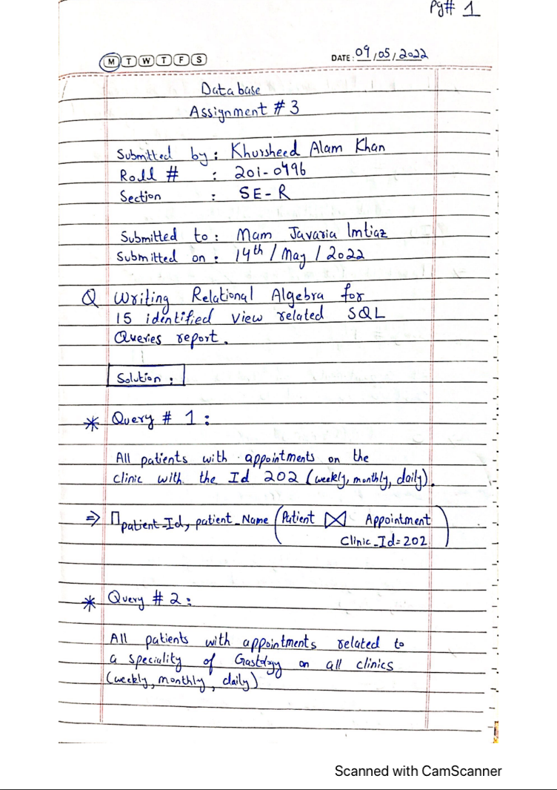The Following Images show the Relational Algebra Queries that I have written for the 15 SQL queries mentioned above:

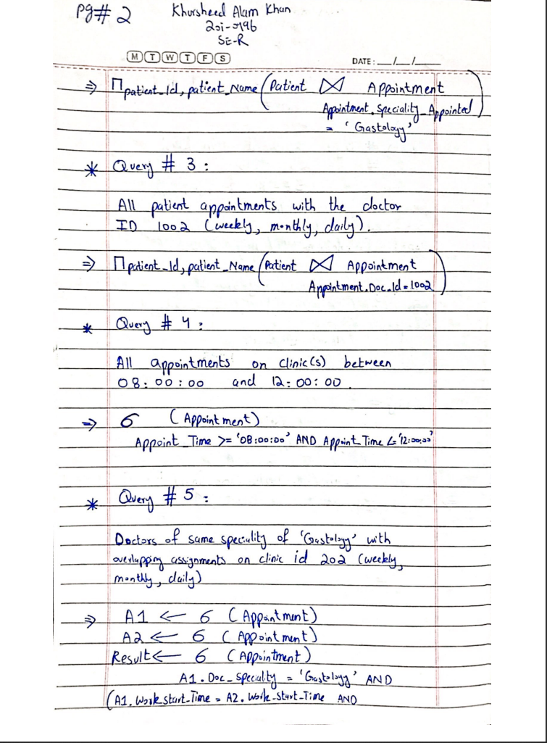

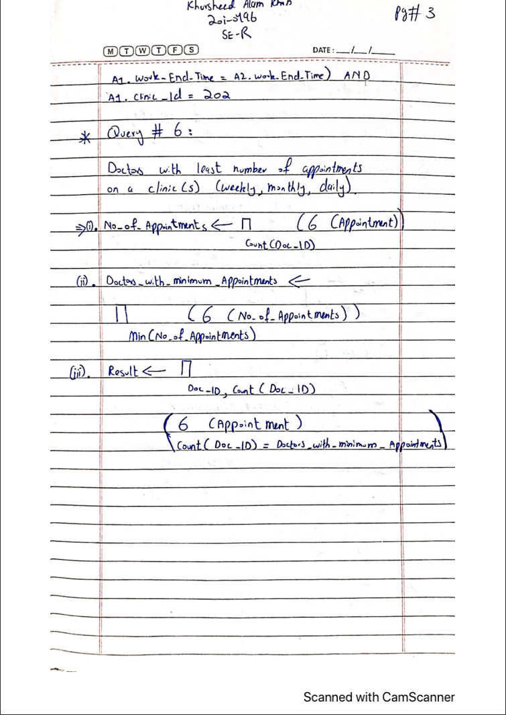

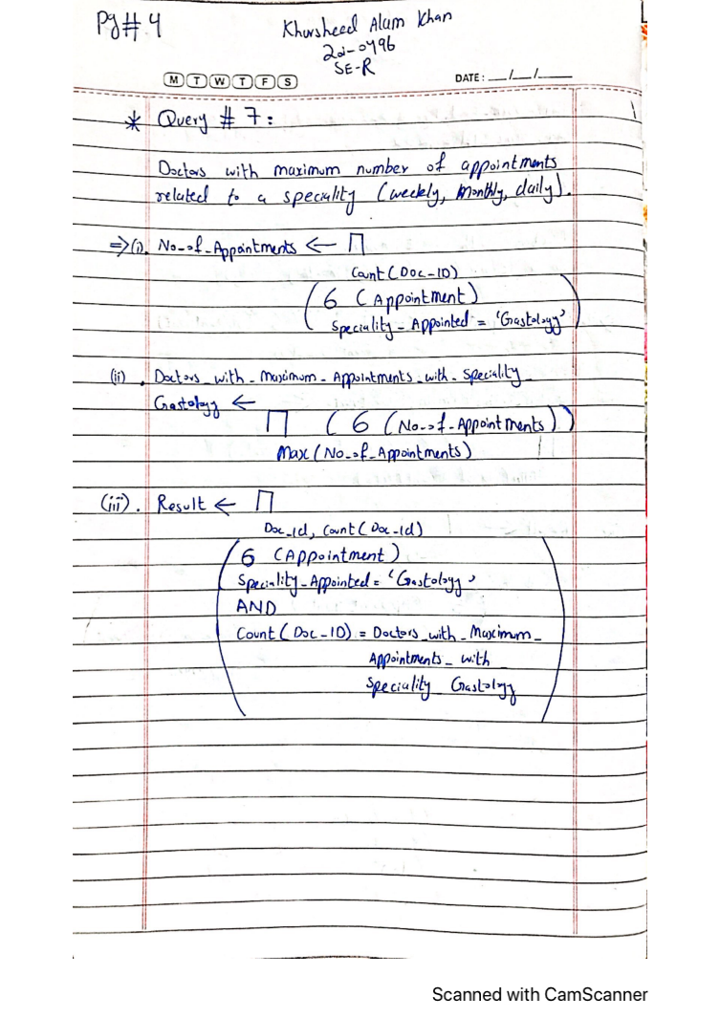

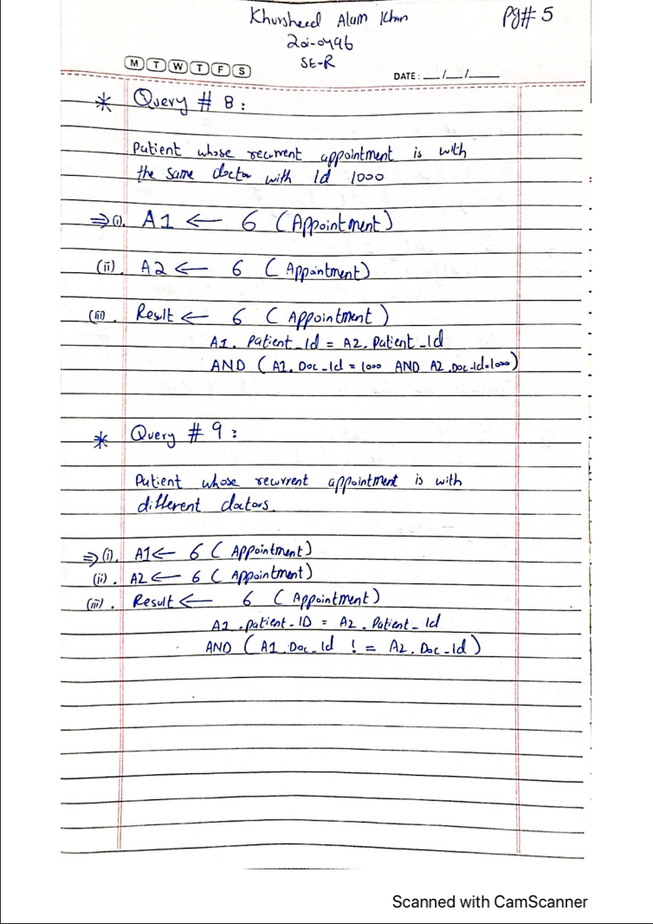

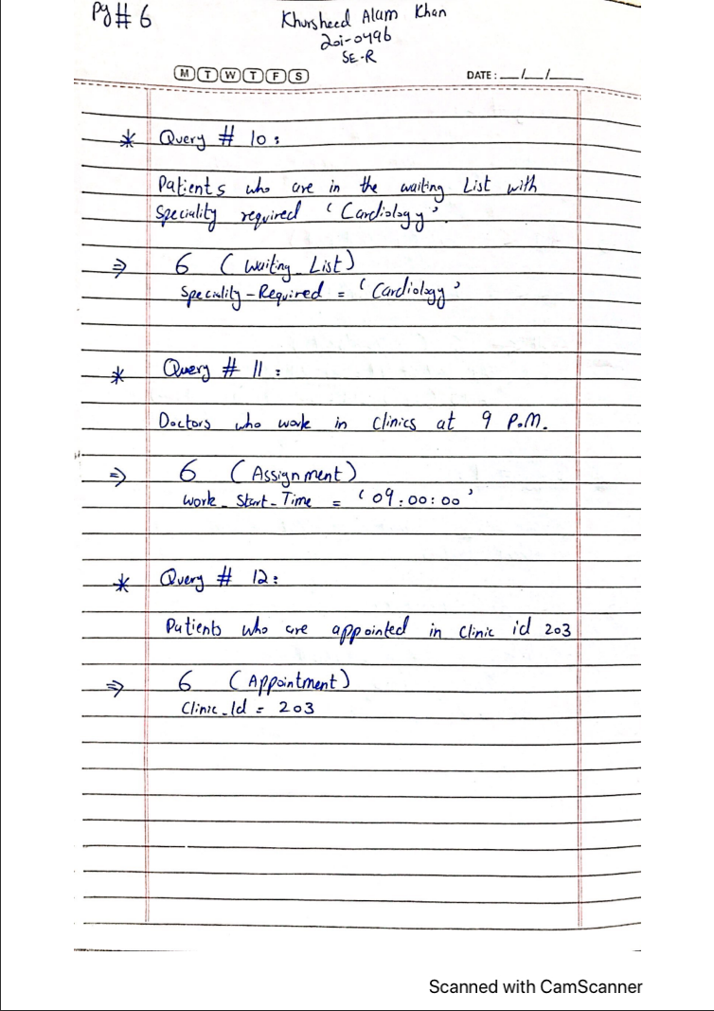

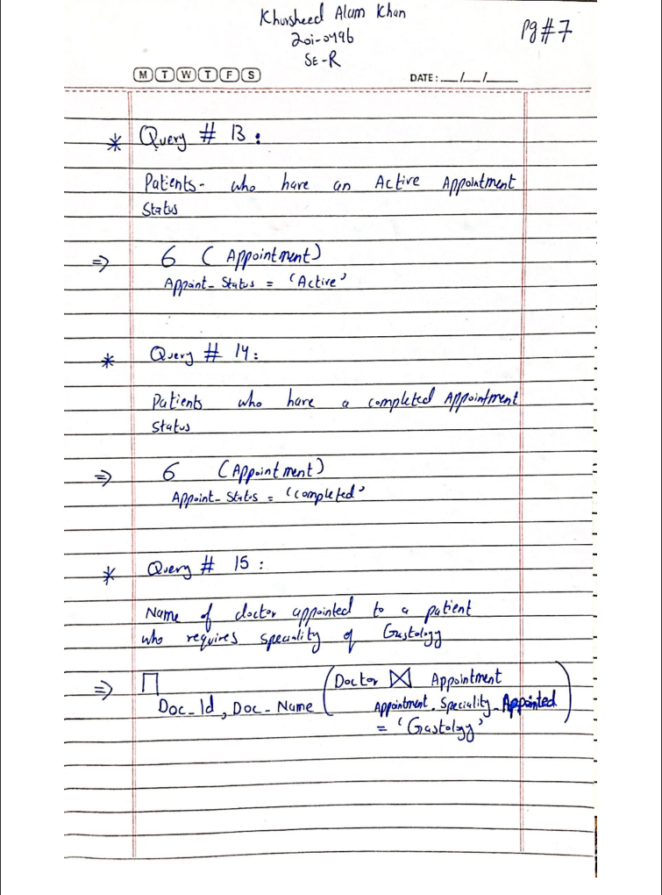

**Snapshot of the Tuples in the Tables and Results of the SQL Queries:** Healthcare Scheduling System

* The Following Images show the Tuples in the Tables for Each Entity Mentioned in my Relational Database Schema:

1. 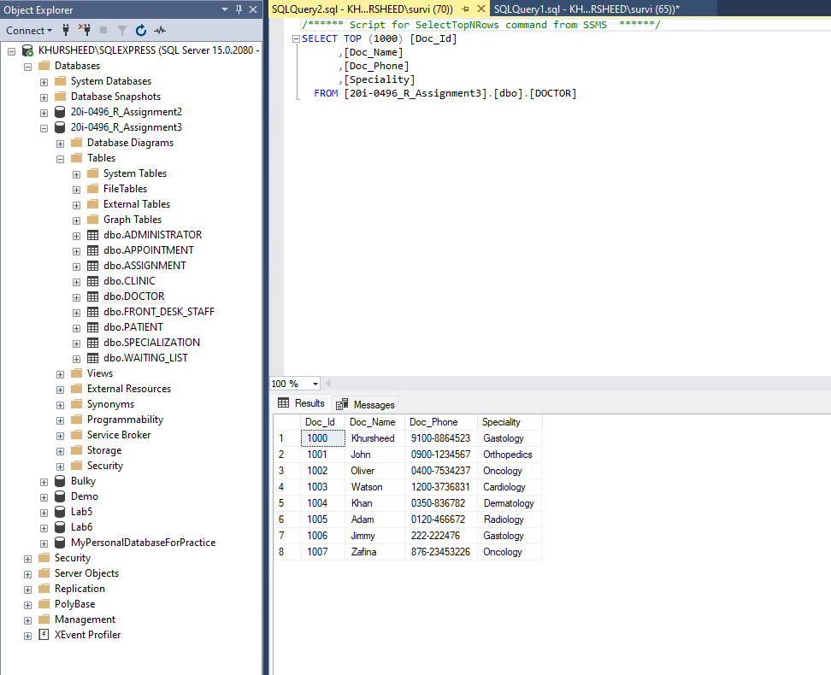**Doctor:**
2. 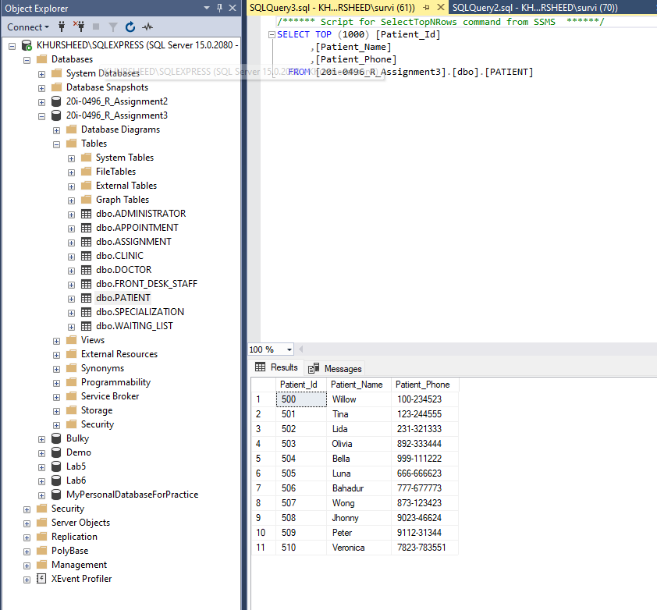**Patient:**
3. 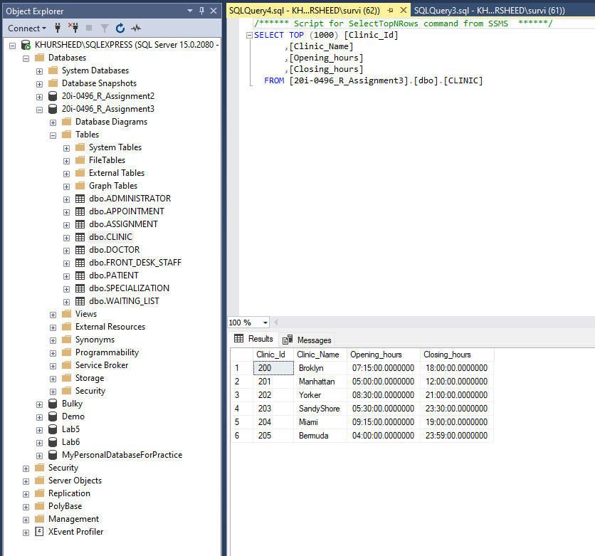**Clinic:**
4. 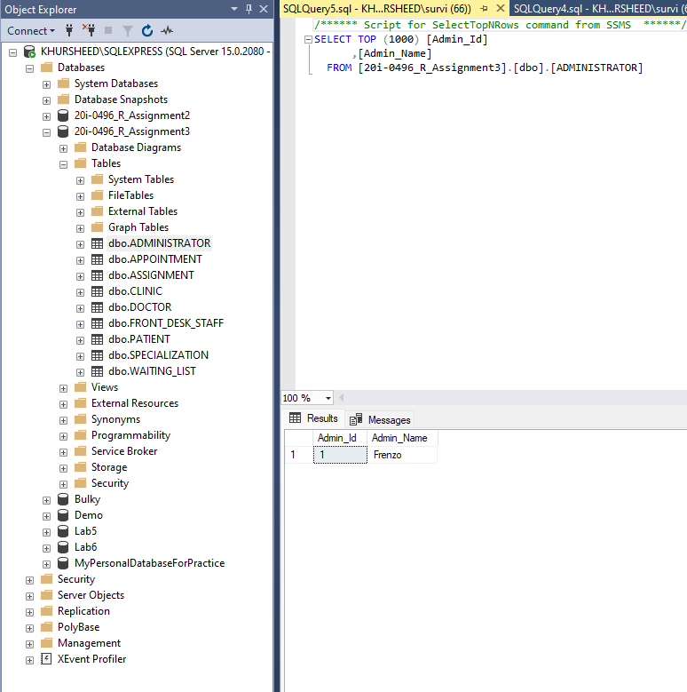**Administrator:**
5. 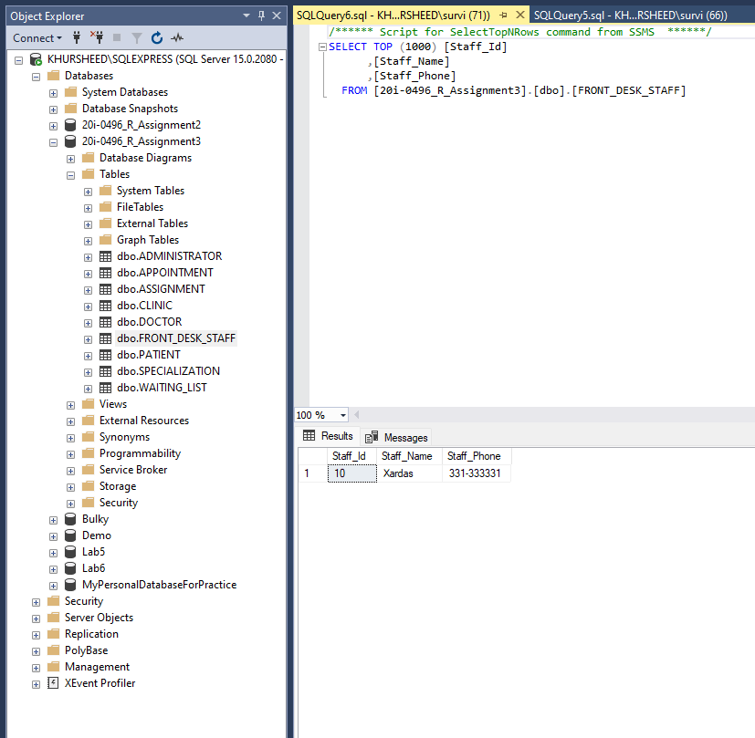**Front_Desk_Staff:**
6. 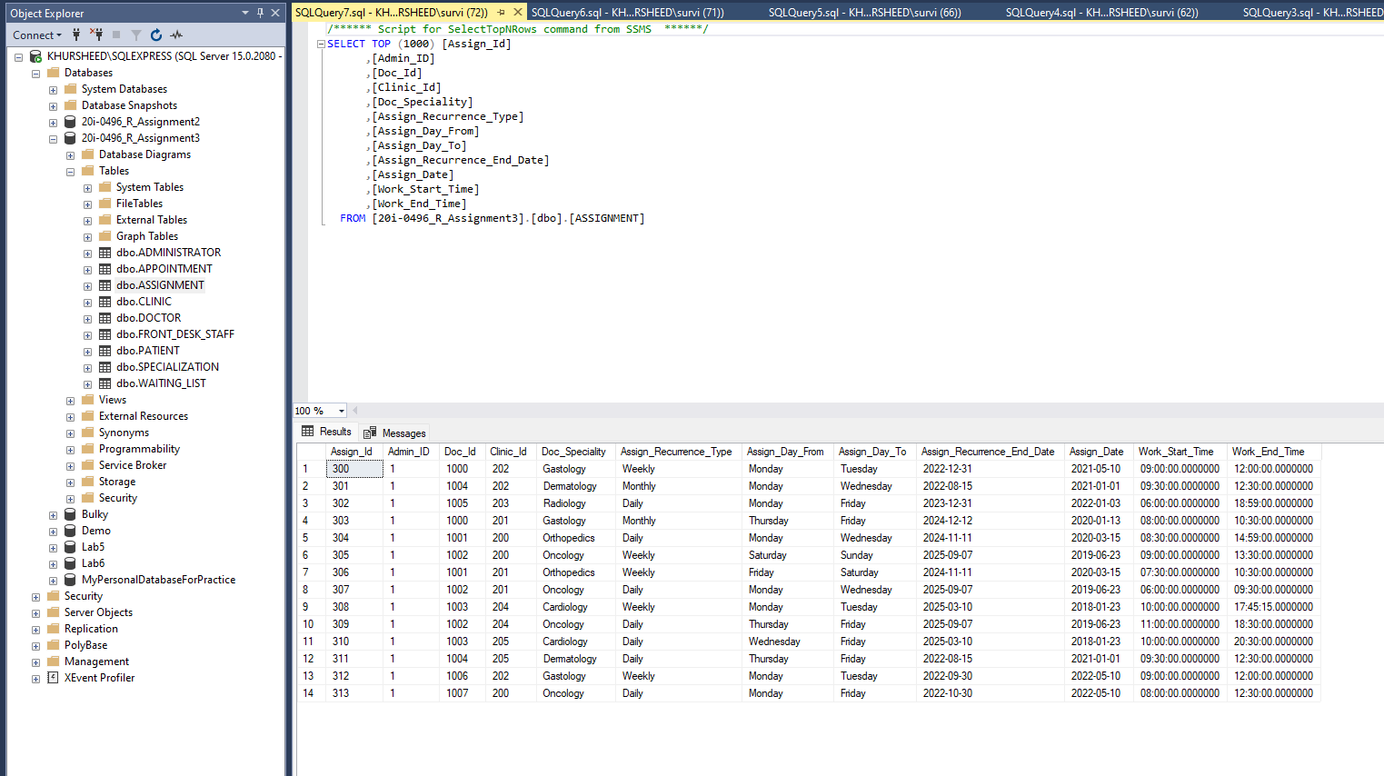**Assignment:**
7. 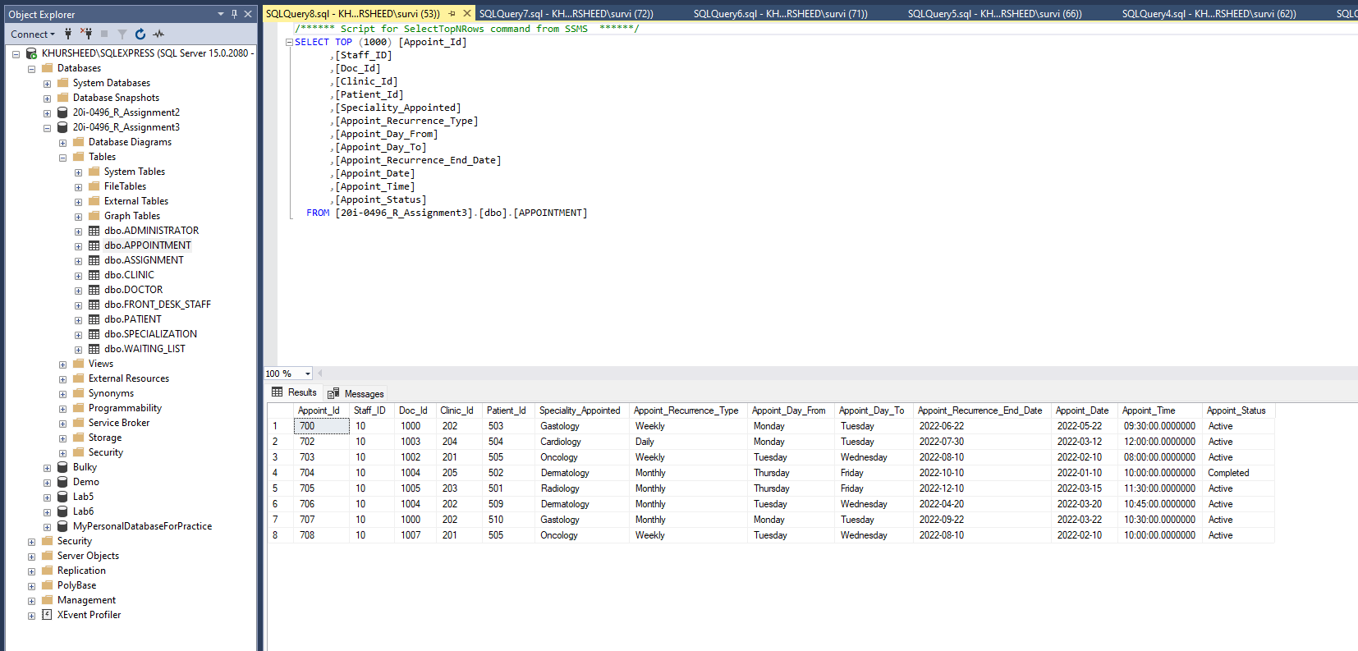**Appointment:**
8. 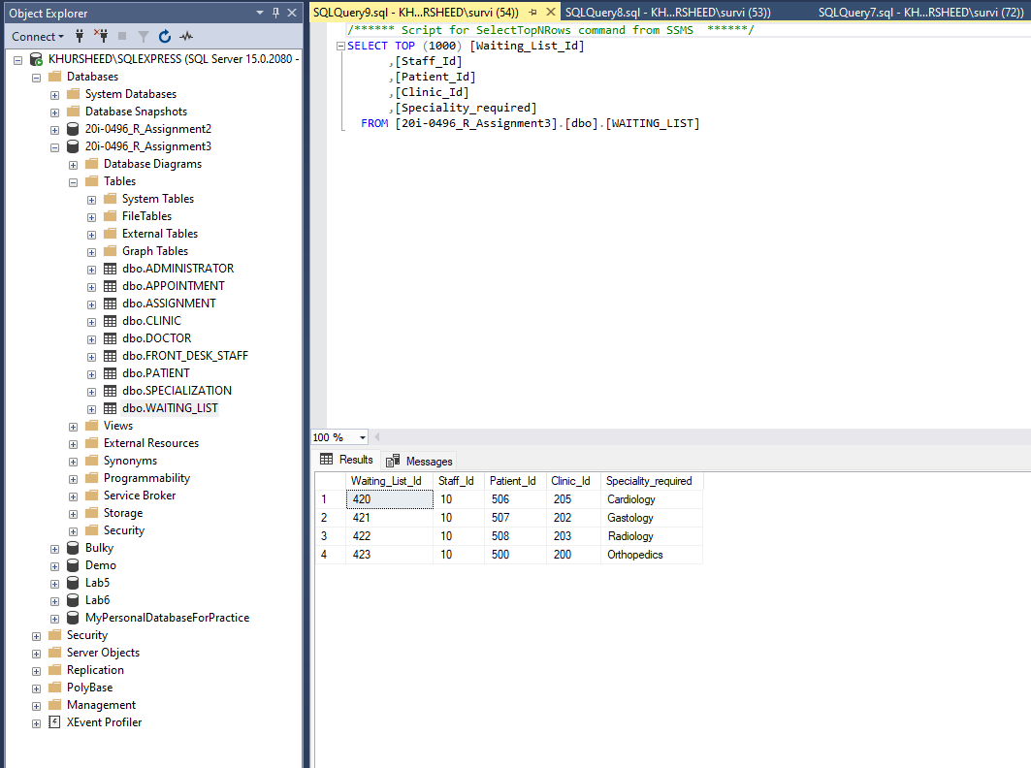**Waiting_List:**
9. 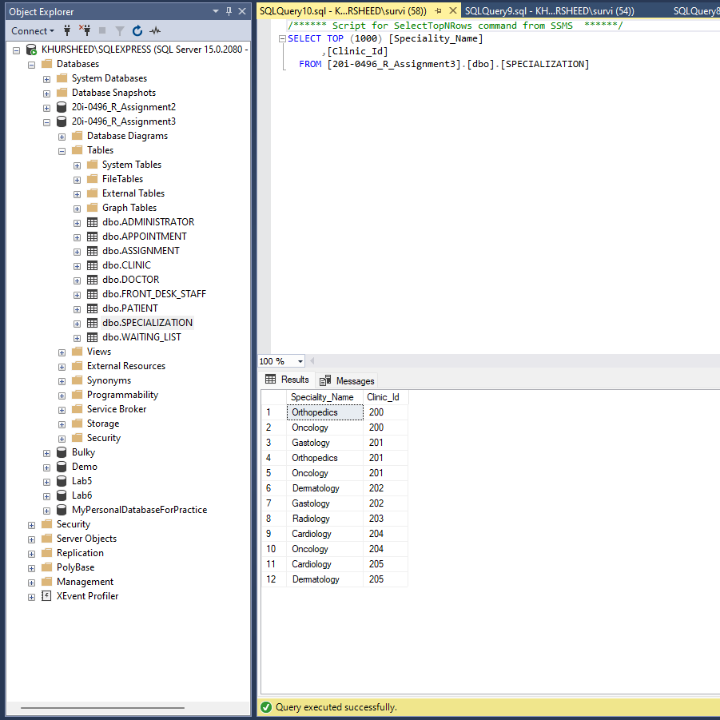**Specialization:**

* The Following Images show the Results for the 15 SQL Queries:
* 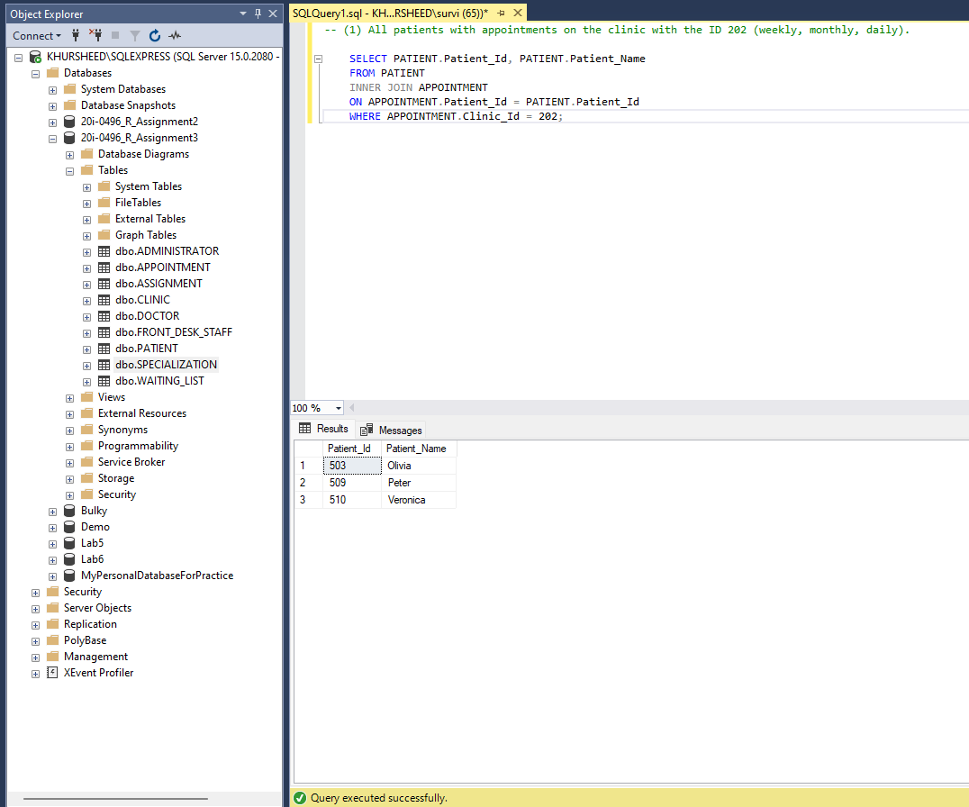(1) All patients with appointments on the clinic with the ID 202 (weekly, monthly, daily).
* (2) All patients with appointments related to a specialty of Gastology on all clinics (weekly, monthly, daily)

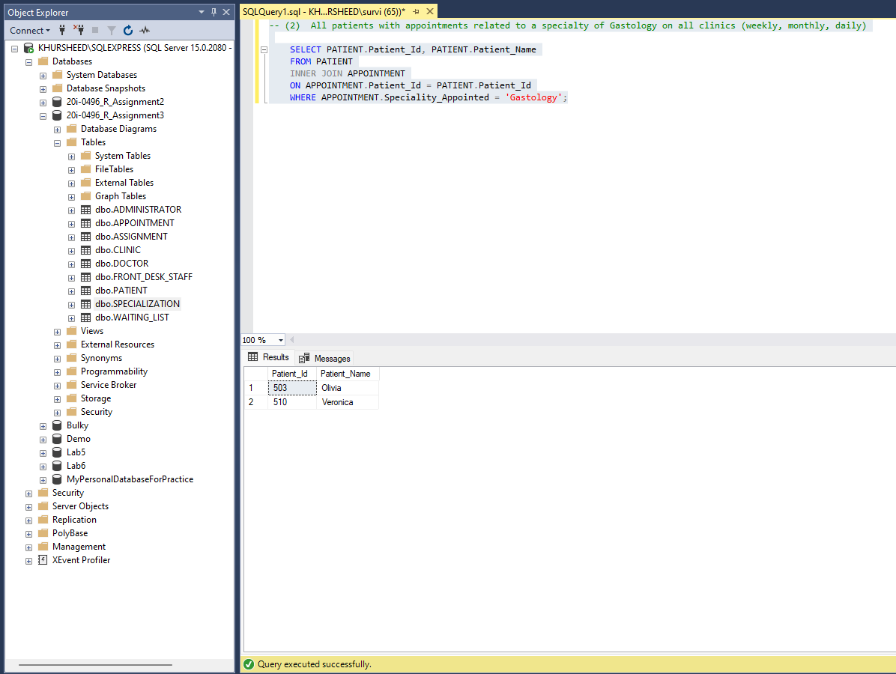

* 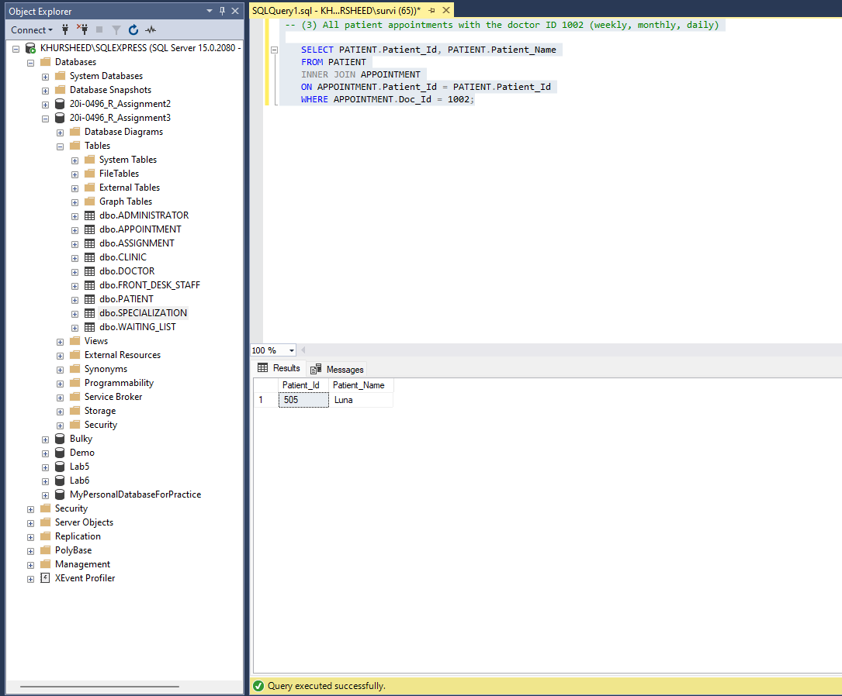(3) All patient appointments with the doctor ID 1002 (weekly, monthly, daily)
* 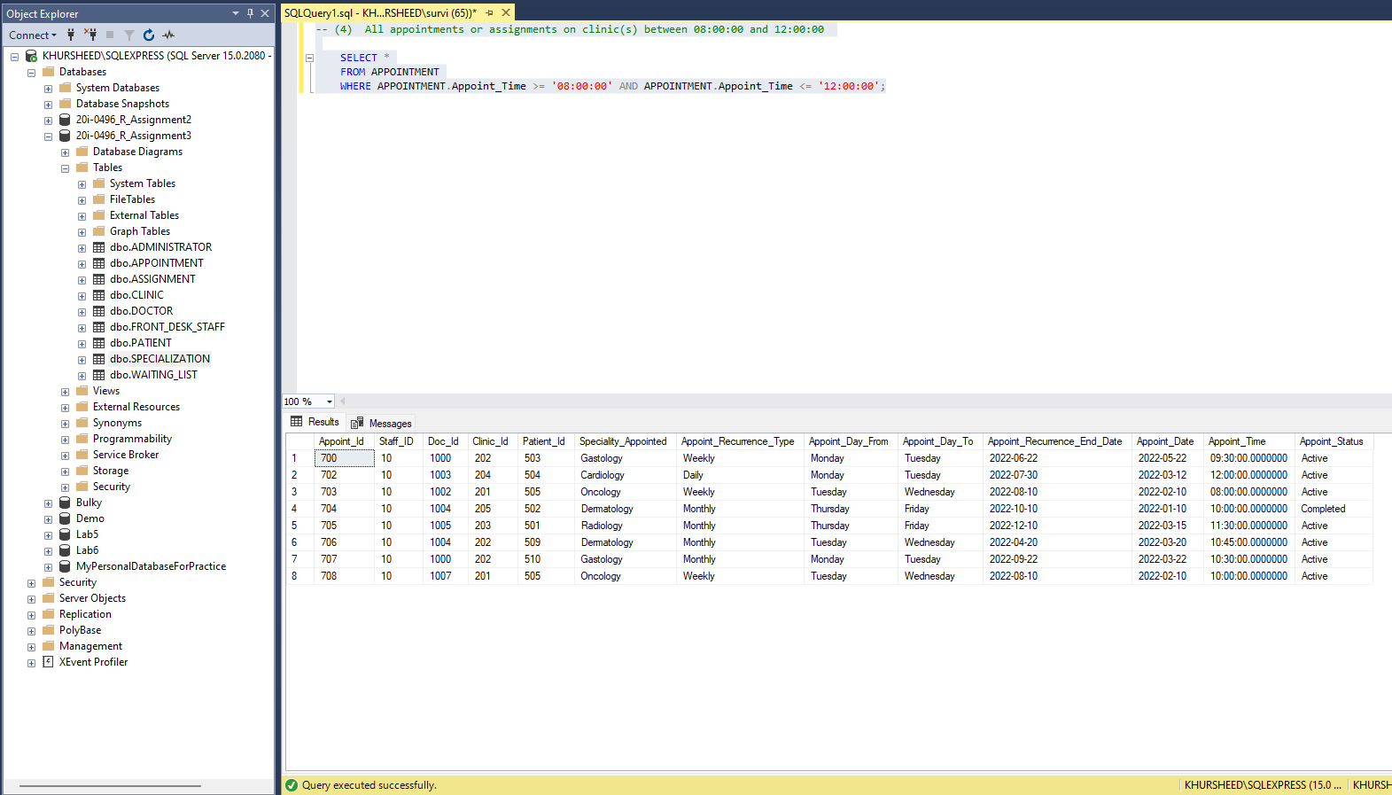(4) All appointments or assignments on clinic(s) between 08:00:00 and 12:00:00
* 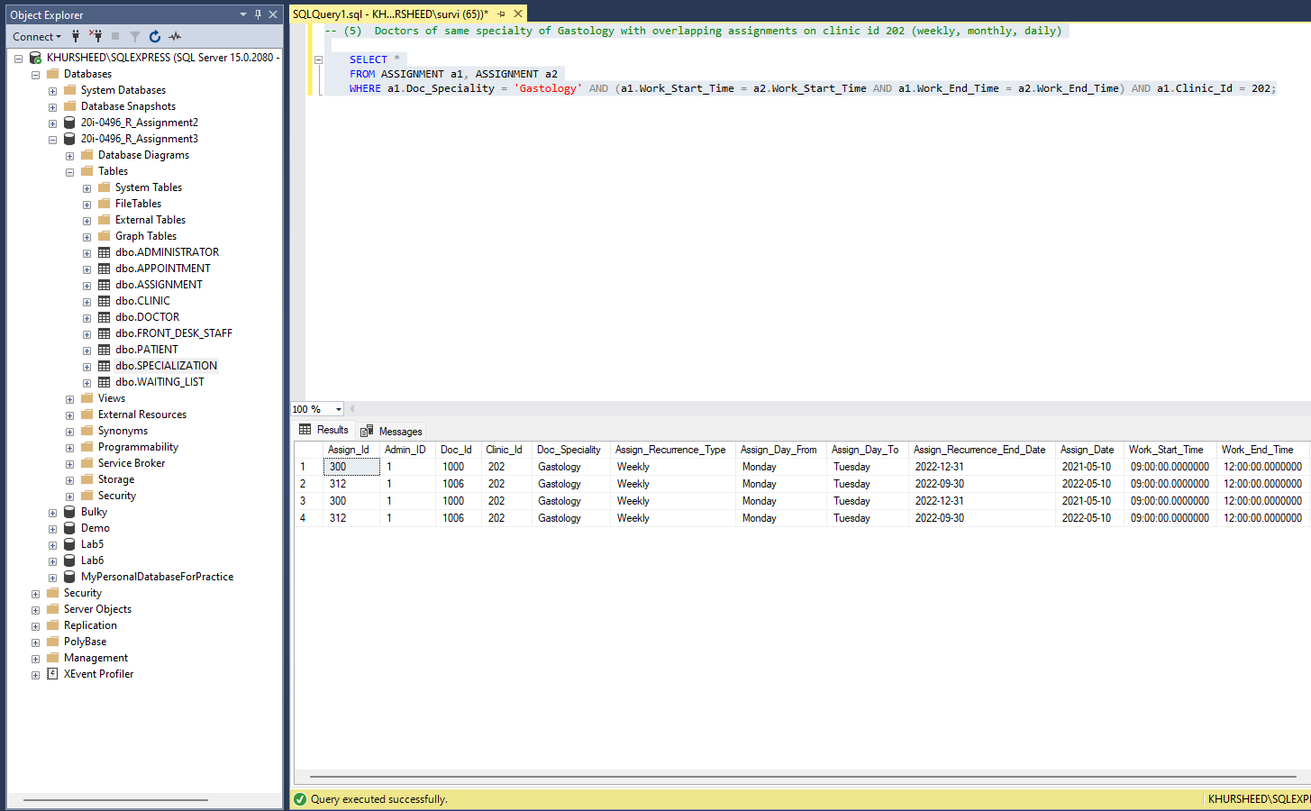(5) Doctors of same specialty of Gastology with overlapping assignments on clinic id 202 (weekly, monthly, daily)
* 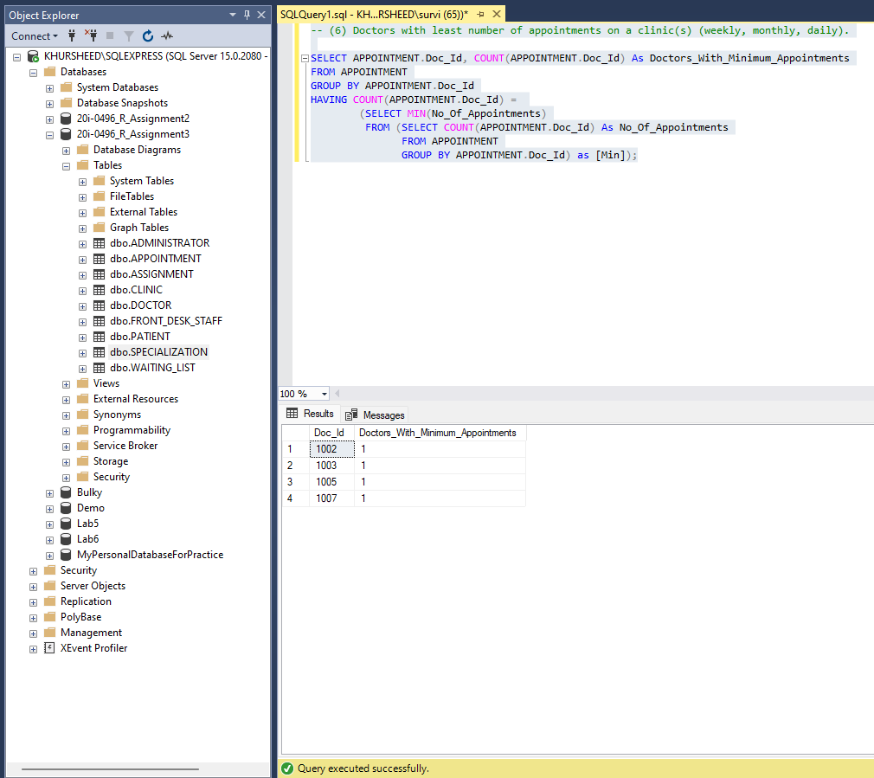(6) Doctors with least number of appointments on a clinic(s) (weekly, monthly, daily).
* 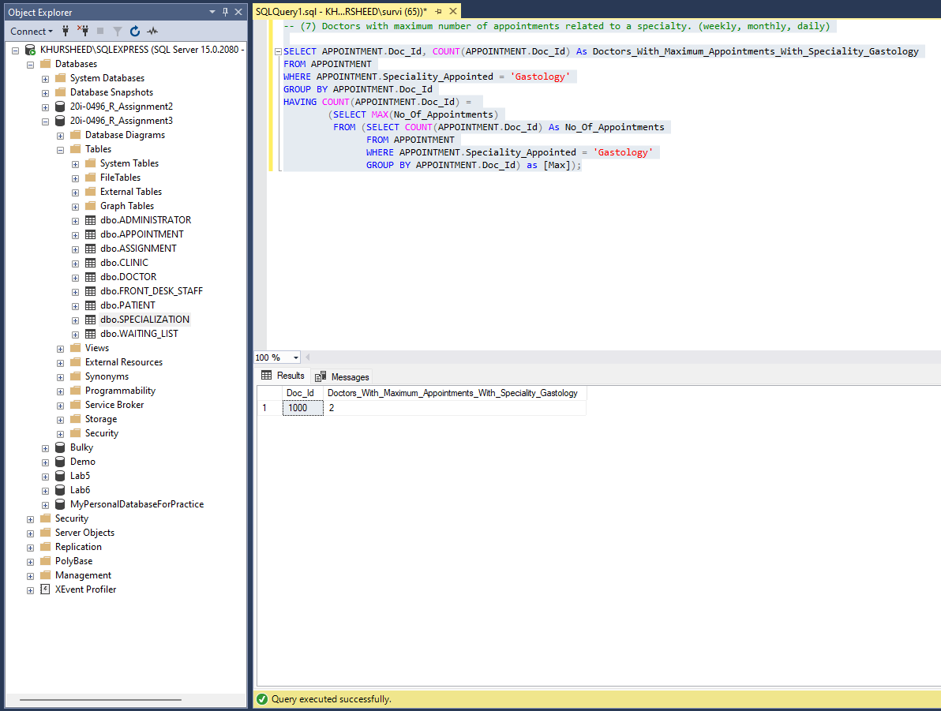(7) Doctors with maximum number of appointments related to a specialty. (weekly, monthly, daily)
* 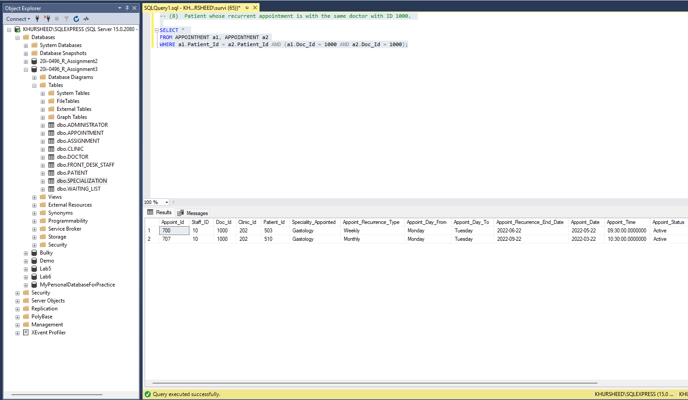(8) Patient whose recurrent appointment is with the same doctor with ID 1000.
* 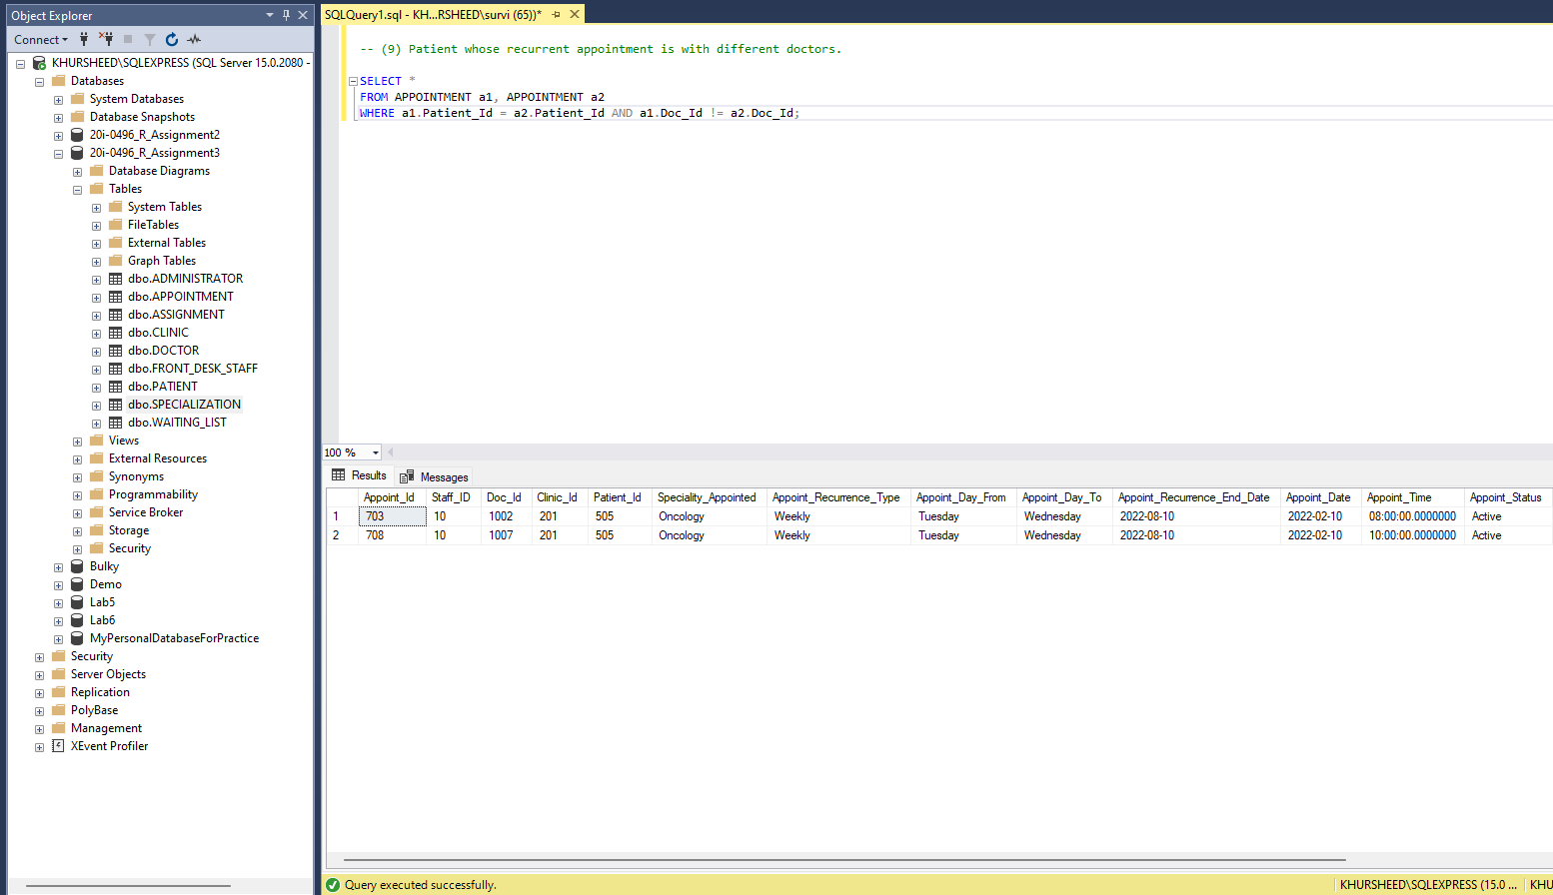(9) Patient whose recurrent appointment is with different doctors.
* 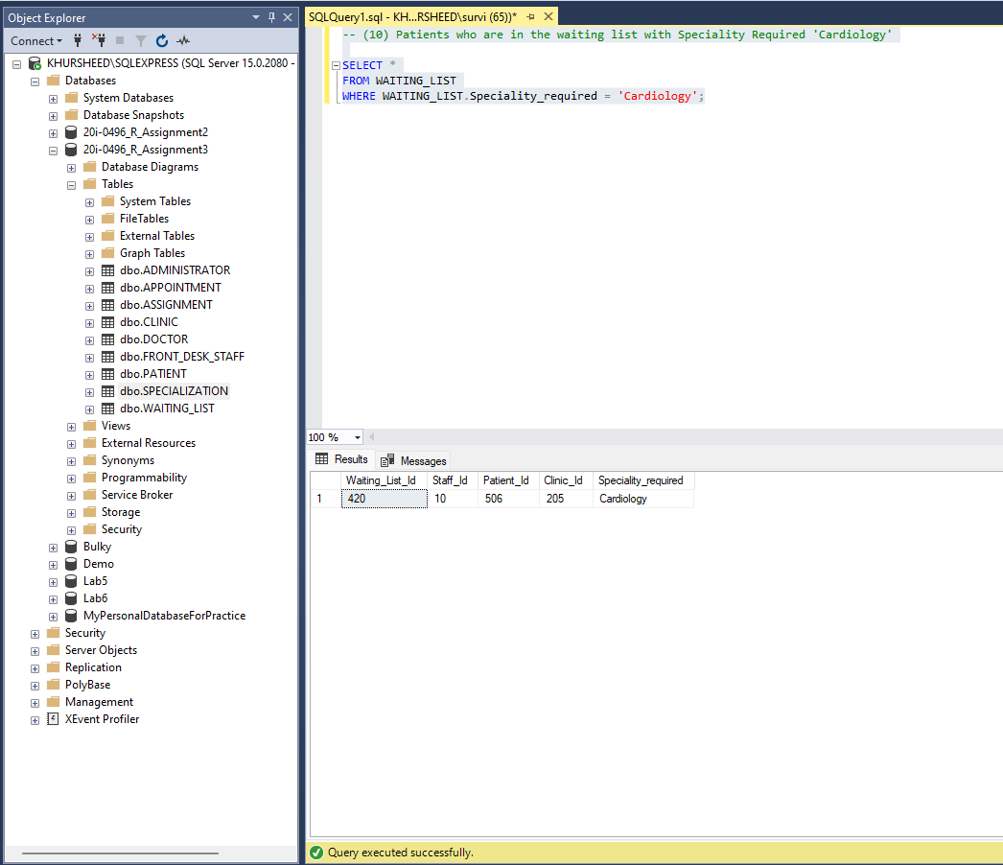(10) Patients who are in the waiting list with Speciality Required 'Cardiology'
* 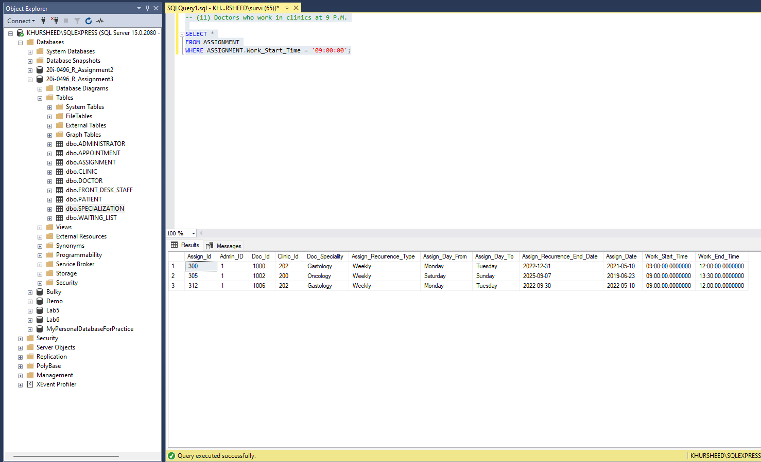(11) Doctors who work in clinics at 9 P.M.
* 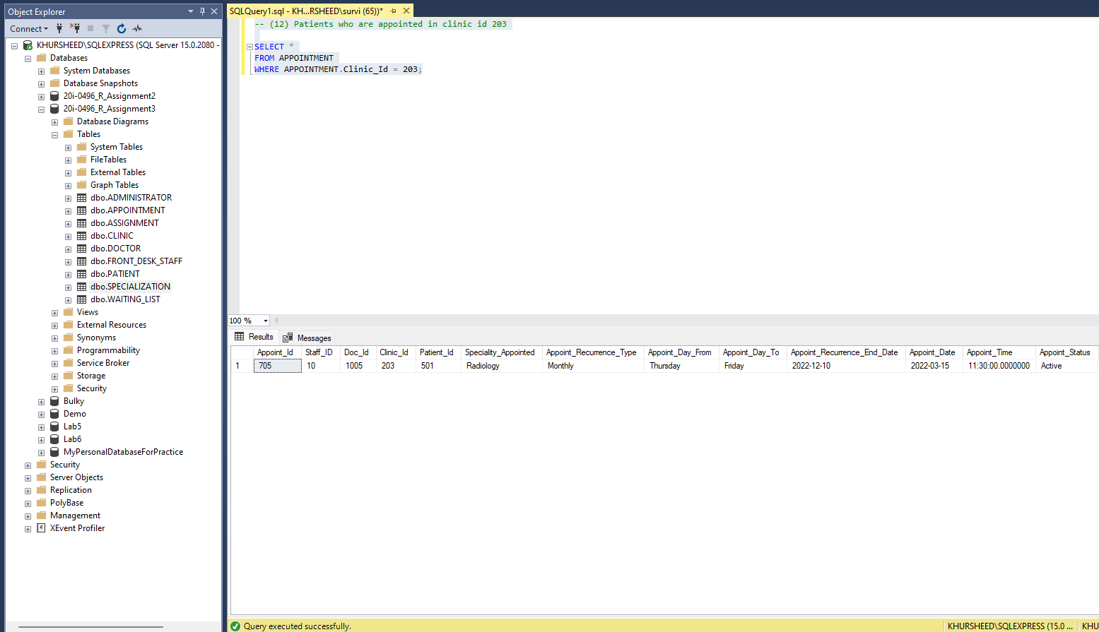(12) Patients who are appointed in clinic id 203
* 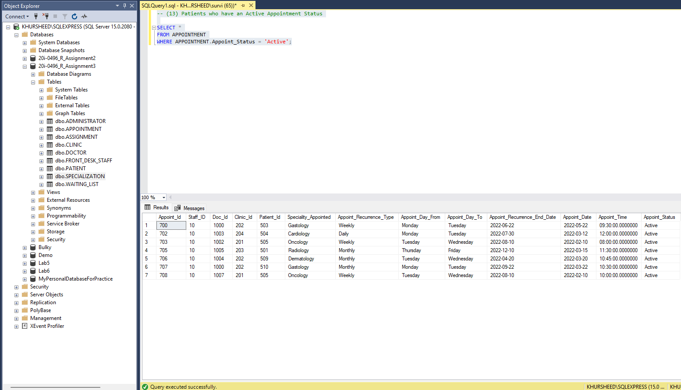(13) Patients who have an Active Appointment Status
* 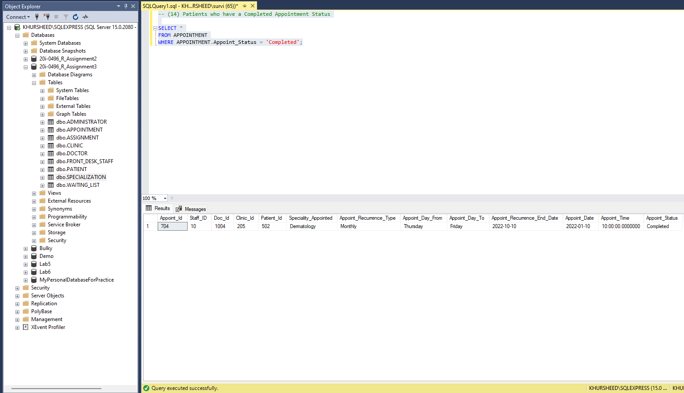(14) Patients who have a Completed Appointment Status
* 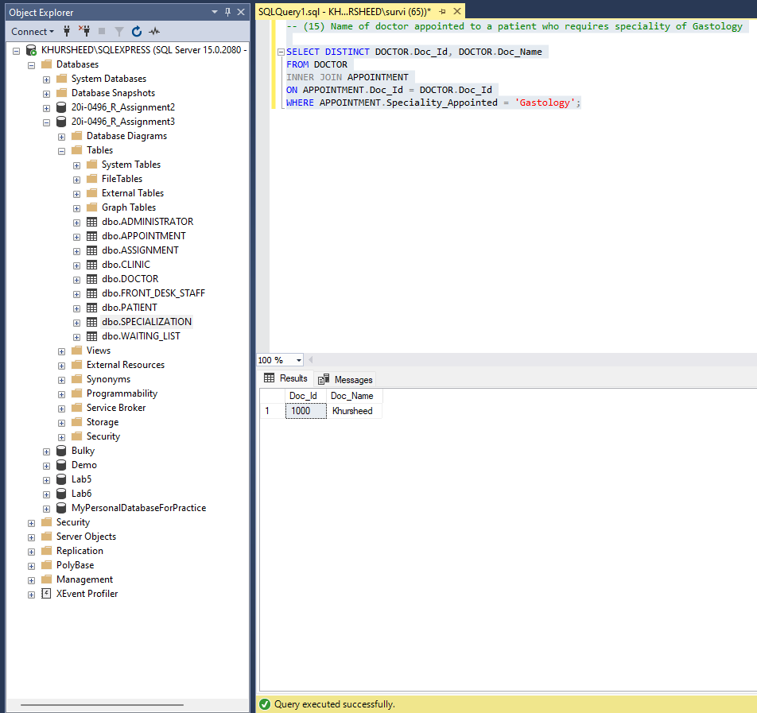(15) Name of doctor appointed to a patient who requires speciality of Gastology